Table of Contents­­

Hadoop V1 (MR1) Architecture 3

Limitations of Hadoop 1 4

YARN (Yet Another Resource Negotiator)/Hadoop V2/MR2 6

5 main components 9

Client 9

Resource Manager 10

Application Master 10

Node Manage 10

Uber Task 10

Different types of MapReduce Cluster Modes 13

RM’s Scheduler component 13

FIFO scheduler 14

Capacity scheduler 14

Fair Share scheduler 14

What is Delay Scheduling? 14

Timeline server 15

Job/Tasks Progress and Updates 15

What is counter? 15

Failures 20

RM Failure 20

Task Failure 20

Hanging tasks 21

Application Master Failure 21

Node Manager Failure 22

Resource Manager Failure 23

MapReduce Flow 23

Mapper 25

Reducer 25

Number of mappers? 26

How to choose number of reducers? 26

MapReduce Tuning 26

Speculative Execution of Task 29

What is Output Committers? 30

Task side-effect files 31

MapReduce Input Formats 31

What is InputSplit? 34

InputFormat and RecordReader 36

Preventing splitting 37

InputFormat Class Hierarchy 38

FileInputFormat 39

CombineFileInputFormat 40

Text Input 40

TextInputFormat 40

KeyValueTextInputFormat 41

NLineInputFormat 41

Processing XML File 42

Binary Input 42

SequenceFileInputFormat 42

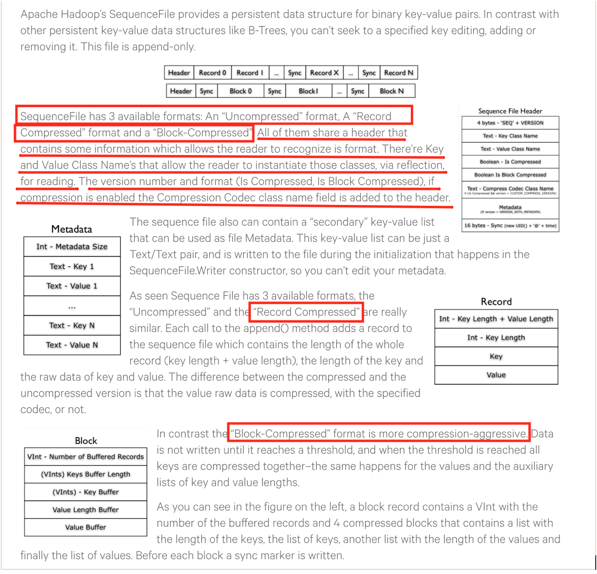 44

SequenceFileAsTextInputFormat 44

SequenceFileAsBinaryInputFormat 45

FixedLengthInputFormat 45

Database Input/Output Format 45

OutputFormat Class Hierarchy 45

FileOutputFormat 46

TextOuputFormat 46

NullOutputFormat 46

Binary Output 46

SequenceFileOutputFormat 47

SequenceFileAsBinaryOutputFormat 47

MapFile, SetFile, ArrayFile, BoolFile OuputFormat 47

DatabaseOutputFormat 48

Multiple Inputs (More Than One Mappers for Different Sets of Input Files) 48

Multiple Outputs (More than one output files from a reducer) 48

Lazy Output 50

MapReduce Features 50

Counters 50

Task Counters 51

Job Counters 53

User-Defined Counters 54

Sorting 55

Partial sort 55

Total sort 56

Secondary sort 58

Joins 63

Map-Side Join 64

Reduce-Side Join 65

# Hadoop V1 (MR1) Architecture

<https://www.youtube.com/watch?v=Rtd0gHl4PBo>

Lot many tasks were done by Job Tracker. So, Job Tracker it was not able to handle more than certain number of tasks. This number we will see later on.

Job Tracker was also a SPOF (Single Point of Failure).

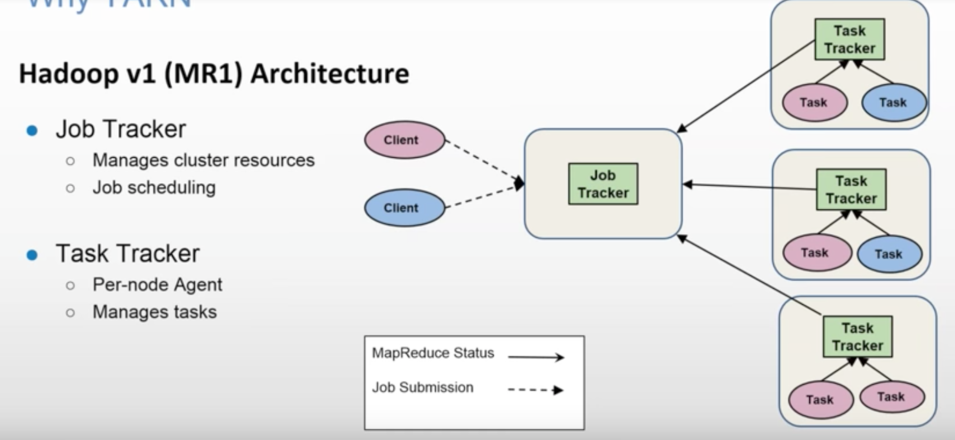

# Limitations of Hadoop 1

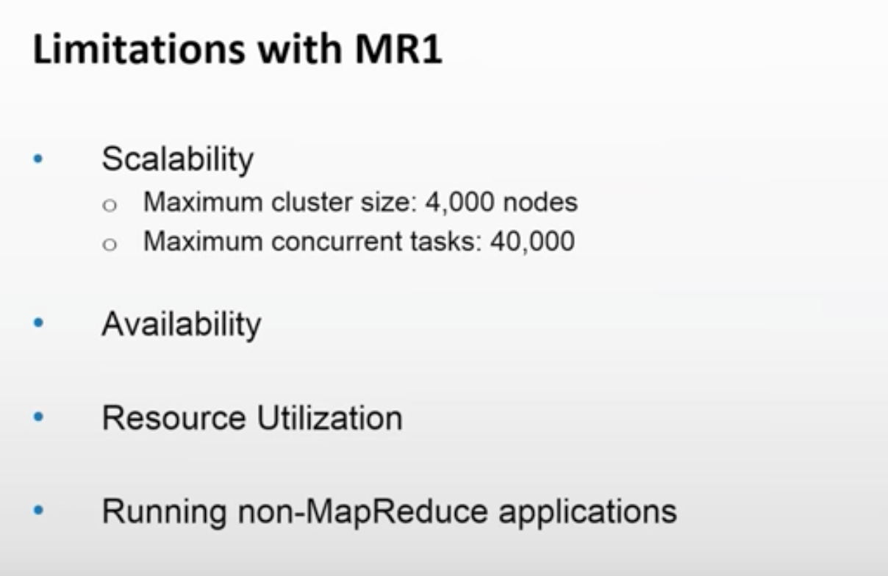

JobTracker is a SPOF. Only traditional MapReduce code can run on Hadoop V1. You cannot run other apps like Storm, Spark, Giraph etc.

*Scalability*

YARN can run on larger clusters than MapReduce 1. MapReduce 1 hits scalability bottlenecks in the region of 4,000 nodes and 40,000 tasks,6 stemming from the fact that the jobtracker has to manage both jobs *and* tasks. YARN overcomes these limitations by virtue of its split resource manager/application master architecture: it is designed to scale up to 10,000 nodes and 100,000 tasks.

In contrast to the jobtracker, each instance of an application—here, a MapReduce job—has a dedicated application master, which runs for the duration of the application.

*Availability*

the large amount of rapidly changing complex state in the jobtracker’s memory (each task status is updated every few seconds, for example) makes it very difficult to retrofit HA into the jobtracker service.

With the jobtracker’s responsibilities split between the resource manager and application master in YARN, making the service highly available became a divide- and-conquer problem: provide HA for the resource manager, then for YARN applications (on a per-application basis). And indeed, Hadoop 2 supports HA both for the resource manager and for the application master for MapReduce jobs.

*Utilization*

In MapReduce 1, each tasktracker is configured with a static allocation of fixed-size “slots,” which are divided into map slots and reduce slots at configuration time. A map slot can only be used to run a map task, and a reduce slot can only be used for a reduce task.

In YARN, a node manager manages a pool of resources, rather than a fixed number of designated slots. MapReduce running on YARN will not hit the situation where a reduce task has to wait because only map slots are available on the cluster, which can happen in MapReduce 1. If the resources to run the task are available, then the application will be eligible for them.

Furthermore, resources in YARN are fine grained, so an application can make a request for what it needs, rather than for an indivisible slot, which may be too big (which is wasteful of resources) or too small (which may cause a failure) for the particular task.

*Multitenancy*

In some ways, the biggest benefit of YARN is that it opens up Hadoop to other types of distributed application beyond MapReduce. MapReduce is just one YARN application among many.

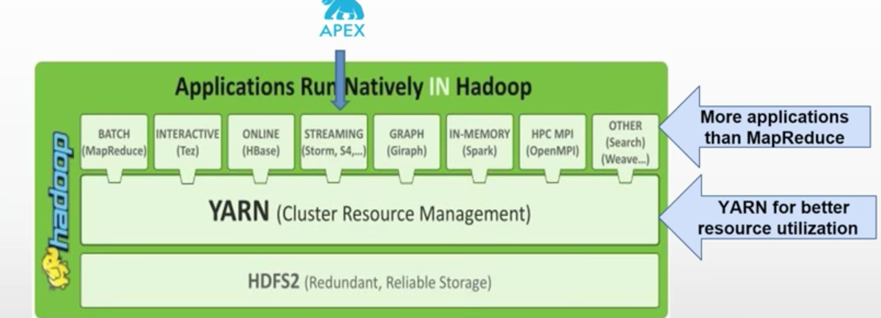

YARN has taken Hadoop beyond Batch Processing.

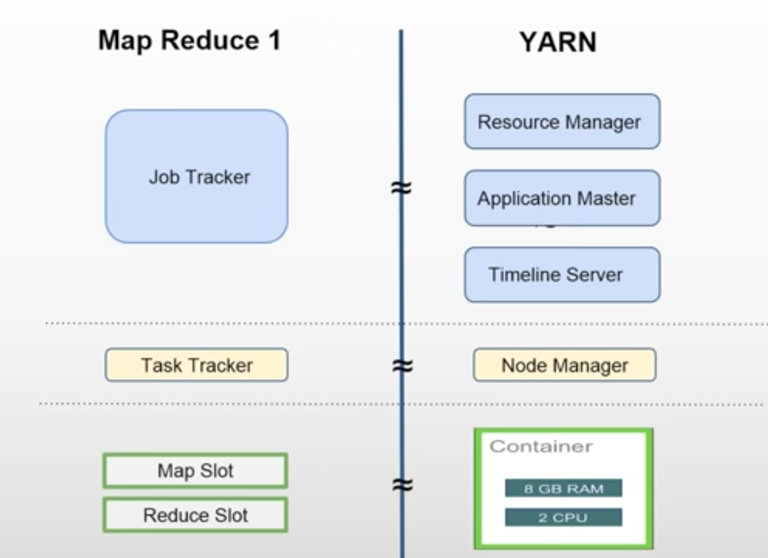

# YARN (Yet Another Resource Negotiator)/Hadoop V2/MR2

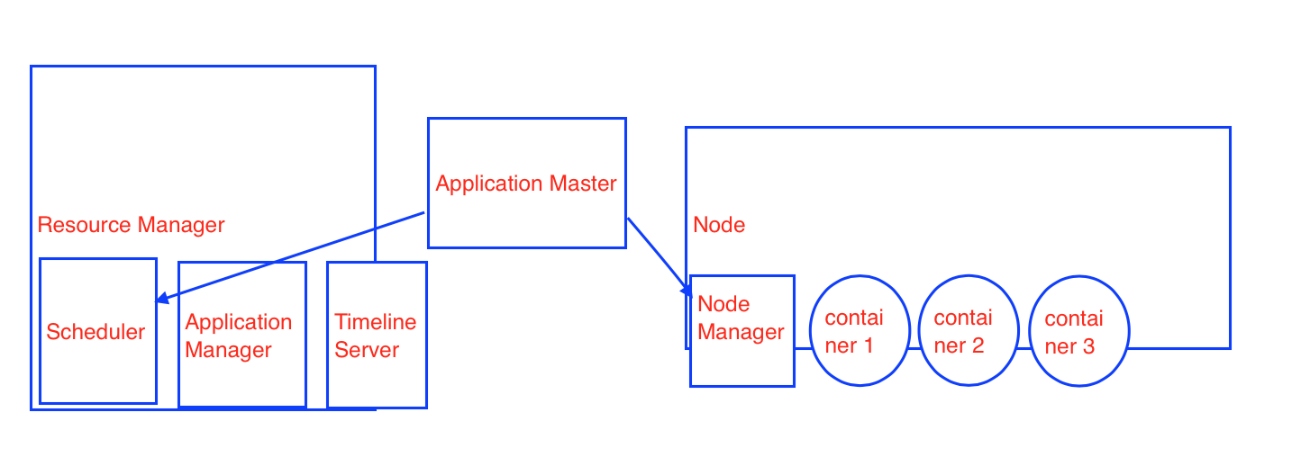

In Hadoop V1, Job Tracker used to many work. In YARN, responsibilities are divided.

Timeline Server keeps the history of all the jobs that were executed.

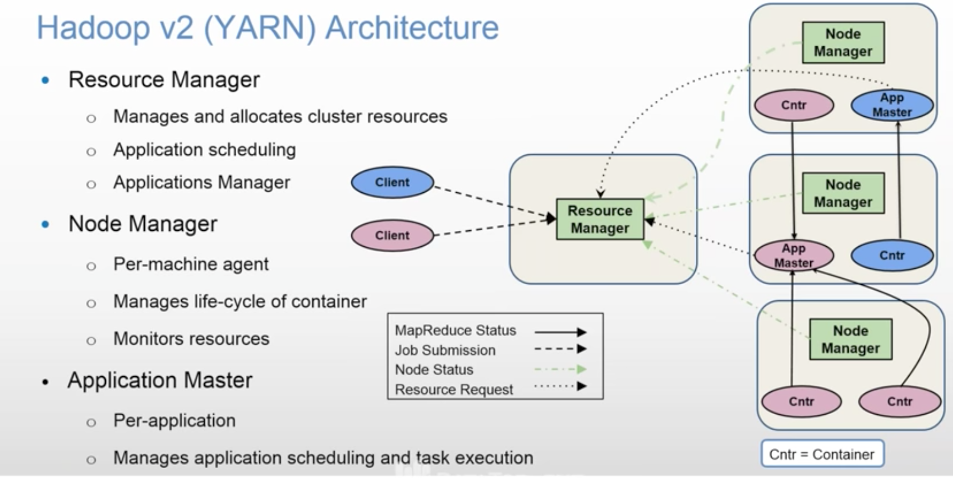

As there are two applications, there are two Application Masters shown in above diagram.

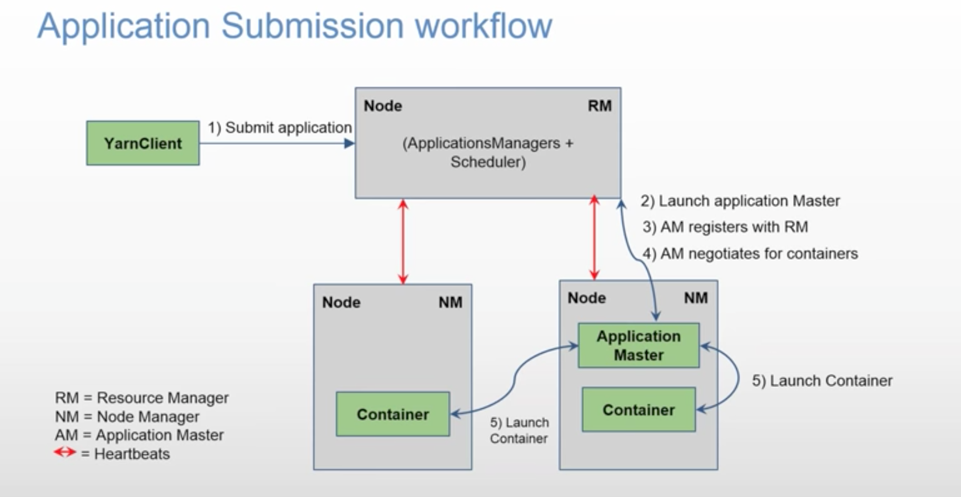

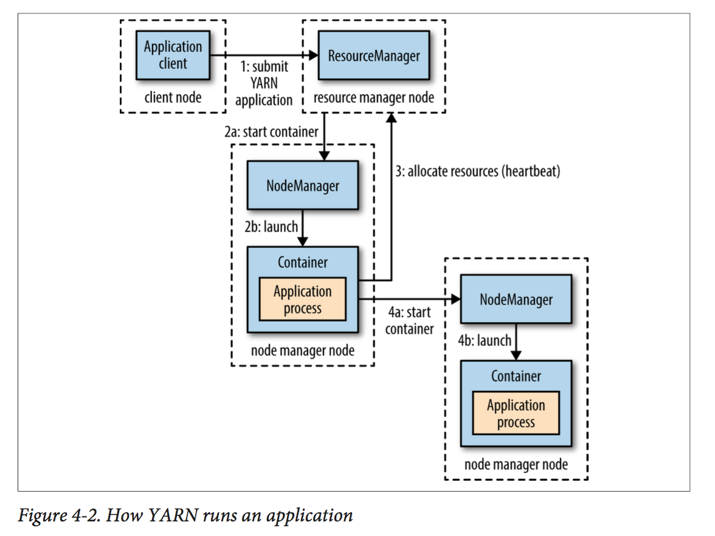

More detailed diagram

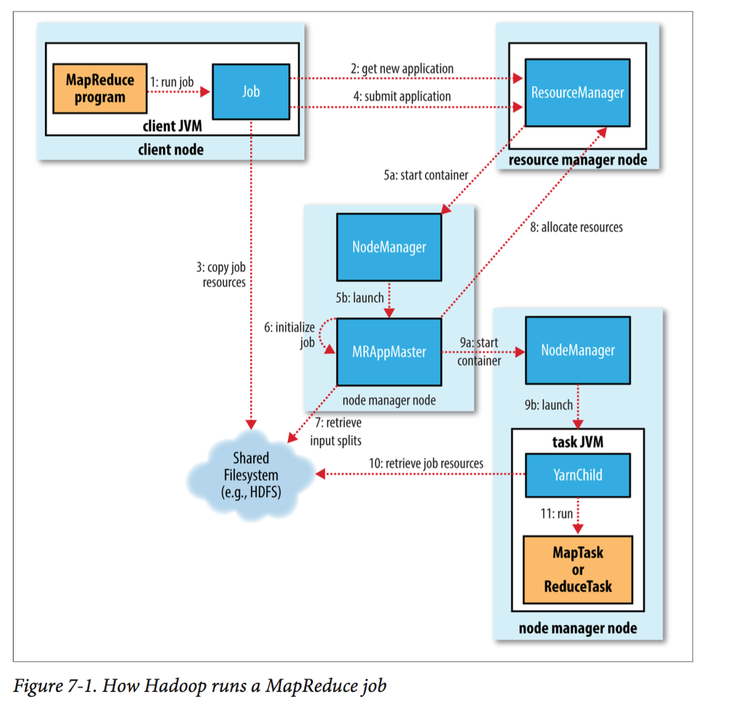

5 main components are involved in running MapReduce job.

* Client
* YARN Resource Manager (has Scheduler and Application Manager)
* YARN Application Master
* YARN Node Manager
* Distributed File System (normally HDFS).

Client asks for new Application ID from RM.

RM returns an Application ID to the client.

Client copies required MapReduce jar file to Shared Filesystem.

Then client submits a job to RM using JobSubmitter class.

JobSubmitter asks InputFormat to create splits. InputSplit object does not contain actual file content. It just has block locations. RecordReader will read contents from these blocks and give it to Mapper as key-value.

Information about InputSplits is also kept in HDFS by JobSubmitter (so client).

You can run a MapReduce job with a single method call: **submit**() on a Job object (you can also call **waitForCompletion**(), which submits the job if it hasn’t been submitted already, then waits for it to finish)

### Resource Manager

The RM’s scheduler allocates a container, and the RM’s Application Manager then launches the application master’s process.

Resource Manager has two important components

* Scheduler
* Application Manager

Application Master sits in between Resource Manager and Node Manager.

There is one and only one Application Master per Application.

It retrieves number of input splits computed by client and kept in HDFS.

Using the number of input splits, it negotiates number of containers from RM’s Scheduler.

It contacts NMs on nodes and tells them to launch containers.

It tracks the progress of tasks running on nodes under the surveillance of Node Manager.

Node Manager’s job is to keep telling Resource Manager about utilized resources and node’s health.

NOTE: Application Master can also be a custom code.

Uber Task **(**Very Important concept)

Based on number of input splits, Application Master decides how many mappers are required and client has told number of reducers using setNumReduceTasks() method.

If job is too small, then Application Master decides to run the MapReduce in its own container sequentially instead of running them in many nodes in parallel. This is called Uber Task.

What qualifies as a small job?

By default, a small job is one that has less than 10 mappers, only one reducer, and an input size that is less than the size of one HDFS block.

(Note that these values may be changed for a job by setting mapreduce.job.ubertask.maxmaps, mapreduce.job.ubertask.maxreduces, and map reduce.job.ubertask.maxbytes.) Uber tasks must be enabled explicitly (for an individual job, or across the cluster) by setting mapreduce.job.ubertask.enable to true.

If the job does not qualify for running as an uber task, then the application master requests containers for all the map and reduce tasks in the job from the resource manager.

Requests for map tasks are made first and with a higher priority than those for reduce tasks, since all the map tasks must complete before the sort phase of the reduce can start. Requests for reduce tasks are not made until 5% of map tasks have completed.

Reduce tasks can run anywhere in the cluster, but requests for map tasks have **data locality** constraints that the scheduler tries to honor.

**By default, each map and reduce task is allocated 1,024 MB of memory and one virtual core.** The values are configurable on a per-job basis via the following properties: mapreduce.map.memory.mb

mapreduce.reduce.memory.mb

mapreduce.map.cpu .vcores

mapreduce.reduce.cpu.vcores.

Once a task has been assigned resources for a container on a particular node by the resource manager’s scheduler, the application master starts the container by contacting the node manager.

The task is executed by a Java application whose main class is **YarnChild**.

The YarnChild runs in a dedicated JVM, so that any bugs in the user-defined map and reduce functions (or even in YarnChild) don’t affect the node manager—by causing it to crash or hang, for example.

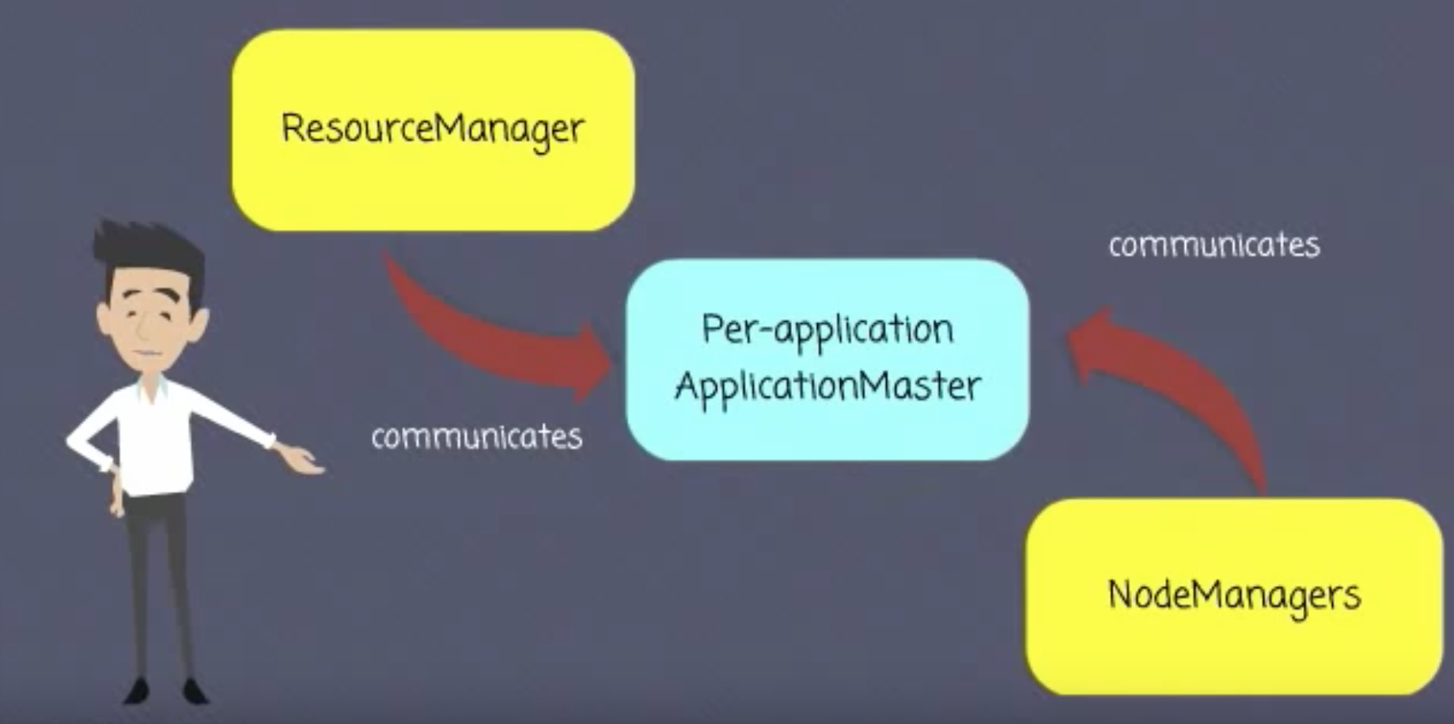

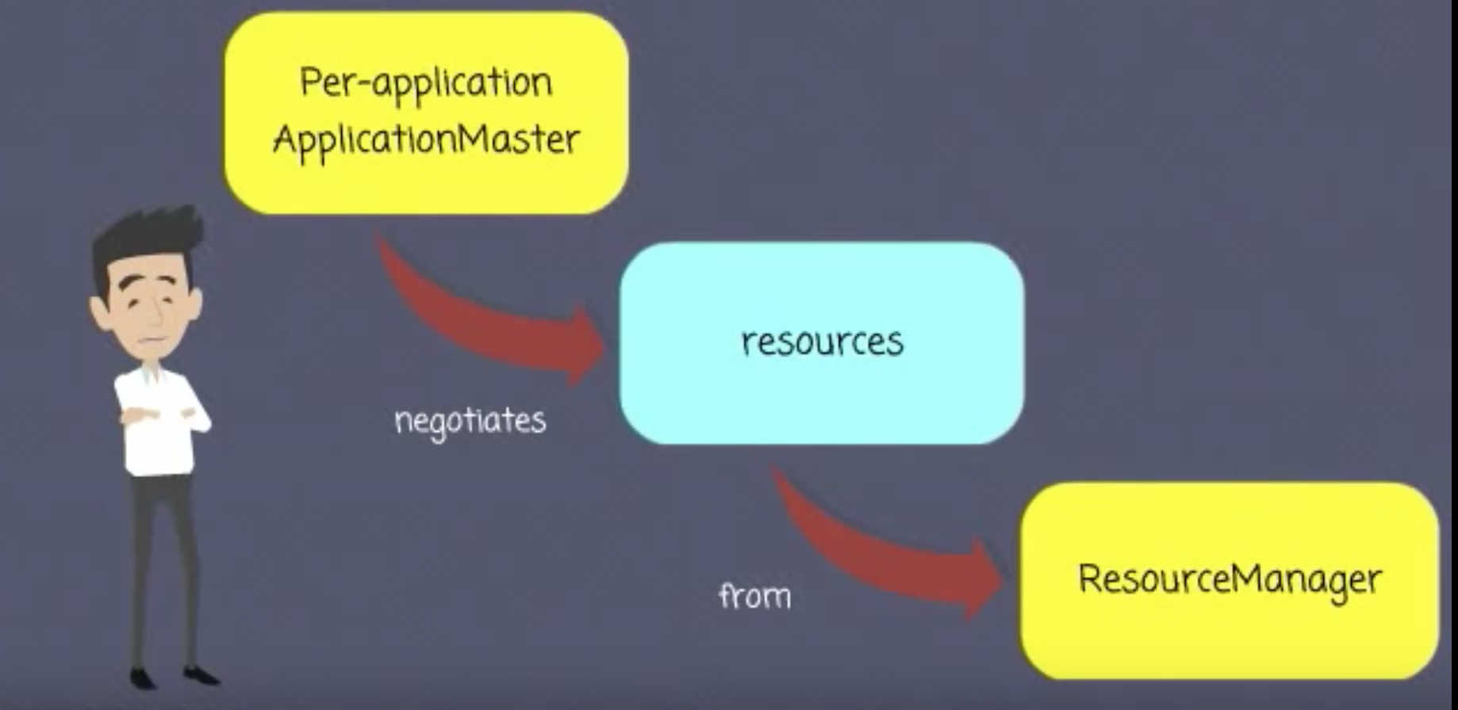

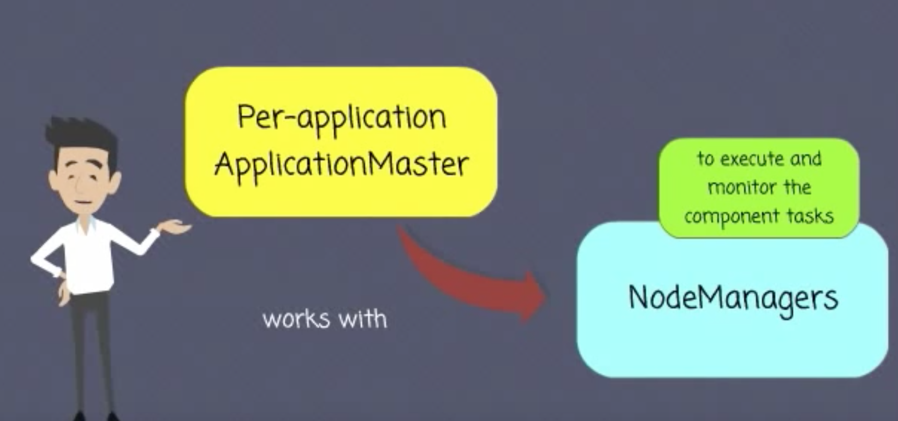

How the communication happens between RM and Application Master?

Application Master is a custom code. If it requires 3 containers, but RM has only 2 available, then RM can go back to Application Master saying come back after some time or you can write Application Master code in such a way that it can accept lower number of containers also.

YARN allows an application to specify locality constraints for the containers it is requesting. Locality constraints can be used to request a container on a specific node or rack, or anywhere on the cluster (off-rack).

Sometimes the locality constraint cannot be met, in which case either no allocation is made or, optionally, the constraint can be loosened.

As per the proximity and availability of the nodes, YARN schedules your job.

It tries to run the job on the closest node where block replica is available. If node is busy because of other containers running in it, then

it finds another node in the same rack. If that is also not available then it goes to a node on another rack.

In the common case of launching a container to process an HDFS block (to run a map task in MapReduce, say), the application will request a container on one of the nodes hosting the block’s three replicas, or on a node in one of the racks hosting the replicas, or, failing that, on any node in the cluster.

You submit a job to RM. RM’s scheduler schedules the job.

**Node Manager** keeps sending heart beats to RM, so that RM know what NMs are up. It also sends utilization of resources information to RM.

Node Manager is responsible to launch a container and killing it when job is over.

# Different types of MapReduce Cluster Modes

For more detailed information about how to write MapReduce code, see Book's Chapter 6 (Developing a MapReduce Application)

It explains how can you switch easily between Standalone, Pseudo Distribution and Cluster modes.

It also explains how can you log and debug the malformed data by setting Job's status and Counter parameter and seeing them in Resource Manager's UI.

# RM’s Scheduler component

will schedule the job in the cluster. So, your job’s state changes from accepted to running.

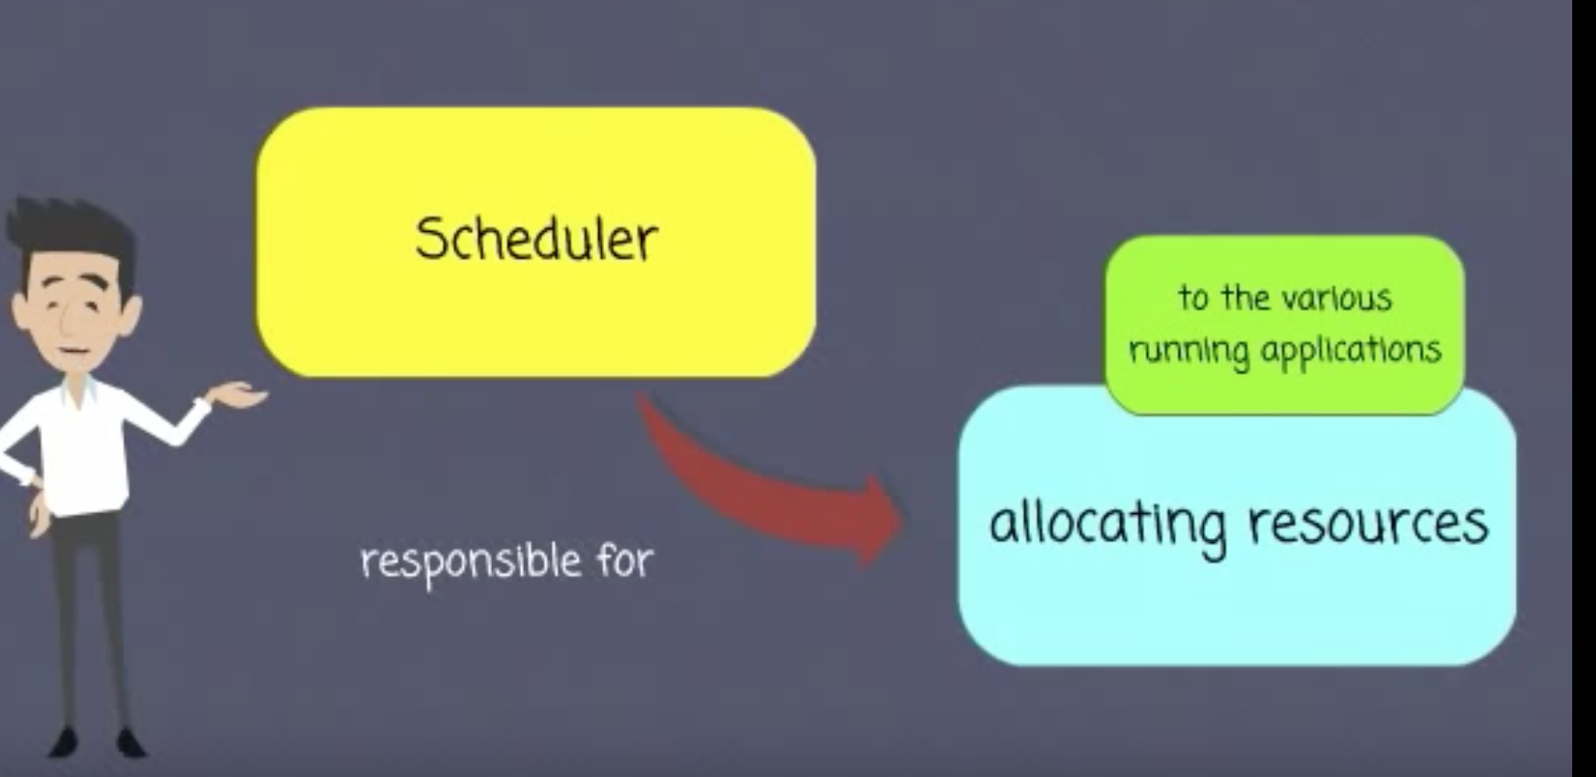

The Scheduler allocates a container, and the Application Manager then launches the Application Master’s process there.

3 different types of schedulers available: (pg. 85 of book)

- FIFO **- default**

- Capacity

- Fair Share

FIFO scheduler queues up the job as it comes and submits them on FIFO basis. If long running job comes first and then short running job, later one has to wait till first one finishes.

This may not be the right scheduling when you want to share the same cluster for multiple jobs.

Capacity scheduler lets you configure multiple queues and set capacity to them. E.g. prod and dev queues with 40% and 60% capacity respectively. When prod job is submitted and if dev job arrives, dev job will start running immediately. Prod job will use 40% capacity (cpu, memory etc) and dev job will use 60%. If another dev job arrives, two dev jobs will share 30%-30% resources.

Fair Share scheduler uses only one queue. It fairly shares the resources (capacity) as and when new job arrives.

You can configure multiple queues in such a way that default is ‘Fair Share’ , but prod queue is overridden with ‘FIFO’ and dev uses the default ‘Faire Share’ (see pg 91 in the book)

For Capacity and Fair Share or mixed types, you need provide queue configuration as shown in the book.

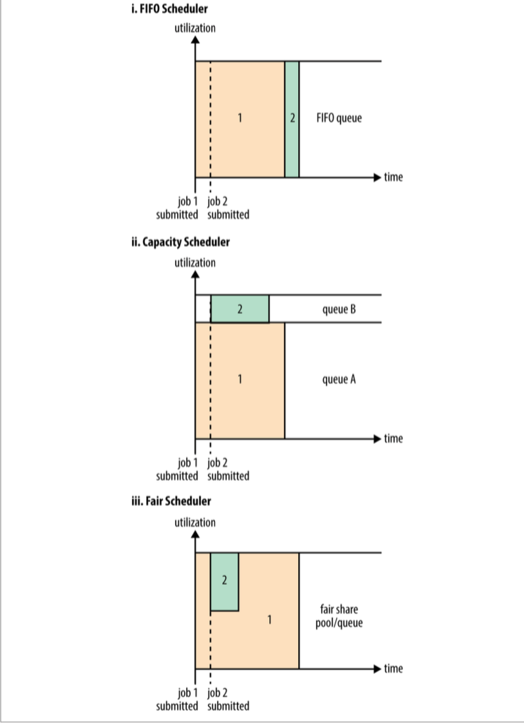

You can submit a job with following parameter specifying a job queue name

-D mapreduce.job.queuename=dev

## What is Delay Scheduling?

Read about data locality first in SampleHadoopProject. It is the most important concept in Hadoop after parallel processing of data.

All the YARN schedulers try to honor **locality** requests. On a busy cluster, if an application requests a particular node, there is a good chance that other containers are running on it at the time of the request. The obvious course of action is to immediately loosen the locality requirement and allocate a container on the same rack. However, it has been observed in practice that waiting a short time (no more than a few seconds) can dramatically increase the chances of being allocated a container on the requested node, and therefore increase the efficiency of the cluster. This feature is called *delay scheduling*, and it is supported by both the Capacity Scheduler and the Fair Scheduler**.**

Timeline server keeps history of jobs that were executed.

## Job/Tasks Progress and Updates

A job and each of its tasks have a *status*, which includes such things as the state of the job or task (e.g., running, successfully completed, failed), the progress of maps and reduces, the values of the job’s counters, and a status message or description (which may be set by user code).

When a task is running, it keeps track of its *progress* (i.e., the proportion of the task completed). For map tasks, this is the proportion of the input that has been processed. For reduce tasks, it’s a little more complex, but the system can still estimate the pro‐ portion of the reduce input processed. It does this by dividing the total progress into three parts, corresponding to the three phases of the shuffle.

For example, if the task has run the reducer on half its input, the task’s progress is 5/6, since it has completed the copy and sort phases (1/3 each) and is halfway through the reduce phase (1/6).

## What is counter?

Tasks (Mapper/Reducer) keeps track of many numbers like number of output record from a mapper. Number of input records to reducer etc.

Along with this, your mapper/reducer code can have its custom counters. E.g. if the input is malformed and cannot be processed, mapper wants to keep the count of those records.

All these counters will be displayed in console as job progresses.

See the example on pg 169 of the book.

The resource manager web UI displays all the running applications with links to the web UIs of their respective application masters, each of which displays further details on the MapReduce job, including its progress.

14/09/12 06:38:11 INFO input.FileInputFormat: **Total input paths to process : 101**

14/09/12 06:38:11 INFO impl.YarnClientImpl: Submitted application

application_1410450250506_0003

14/09/12 06:38:12 INFO mapreduce.Job: **Running job: job_1410450250506_0003**

14/09/12 06:38:26 INFO mapreduce.Job: map 0% reduce 0%

...

14/09/12 06:45:24 INFO mapreduce.Job: **map 100% reduce 100%**

14/09/12 06:45:24 INFO mapreduce.Job: **Job job_1410450250506_0003 completed**

**successfully**

14/09/12 06:45:24 INFO mapreduce.Job: **Counters: 49**

File System Counters

FILE: Number of bytes read=93995

FILE: Number of bytes written=10273563

FILE: Number of read operations=0

FILE: Number of large read operations=0

FILE: Number of write operations=0

HDFS: Number of bytes read=33485855415

HDFS: Number of bytes written=904

HDFS: Number of read operations=327

HDFS: Number of large read operations=0

HDFS: Number of write operations=16

Job Counters

**Launched map tasks=101**

**Launched reduce tasks=8**

Data-local map tasks=101

Total time spent by all maps in occupied slots (ms)=5954495

Total time spent by all reduces in occupied slots (ms)=74934

Total time spent by all map tasks (ms)=5954495

Total time spent by all reduce tasks (ms)=74934

Total vcore-seconds taken by all map tasks=5954495

Total vcore-seconds taken by all reduce tasks=74934

Total megabyte-seconds taken by all map tasks=6097402880

Total megabyte-seconds taken by all reduce tasks=76732416

Map-Reduce Framework

**Map input records=1209901509**

**Map output records=1143764653**

Map output bytes=10293881877

Map output materialized bytes=14193

**Input split bytes=14140**

Combine input records=1143764772

**Combine output records=234**

Reduce input groups=100

Reduce shuffle bytes=14193

Reduce input records=115

Reduce output records=100

**Spilled Records=379**

**Shuffled Maps =808**

Failed Shuffles=0

Merged Map outputs=808

GC time elapsed (ms)=101080

CPU time spent (ms)=5113180

Physical memory (bytes) snapshot=60509106176

Virtual memory (bytes) snapshot=167657209856

Total committed heap usage (bytes)=68220878848

Shuffle Errors

BAD_ID=0

CONNECTION=0

IO_ERROR=0

WRONG_LENGTH=0

WRONG_MAP=0

WRONG_REDUCE=0

File Input Format Counters

Bytes Read=33485841275

File Output Format Counters

Bytes Written=90

During the course of the job, the client receives the latest status by polling the application master every second

When the application master receives a notification that the last task for a job is complete, it changes the status for the job to “successful.” Then, when the Job polls for status, it learns that the job has completed successfully, so it prints a message to tell the user and then returns from the waitForCompletion() method. Job statistics and counters are printed to the console at this point.

“Orelly.Hadoop.The.Definitive.Guide.4th.Edition2015.3.pdf” book doesn’t show an example using YarnClient. See Chapter 6 (Developing a MapReduce Application)

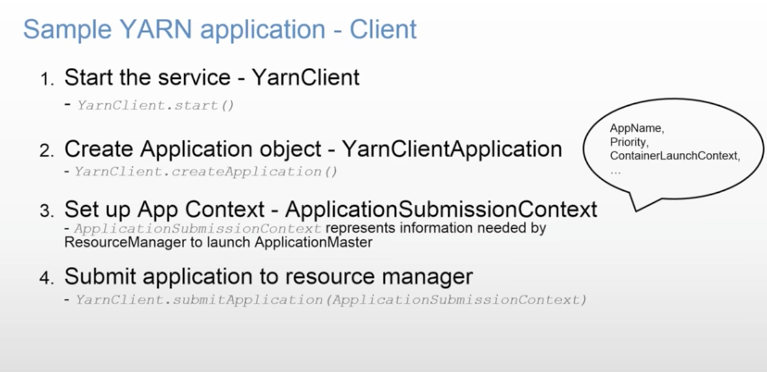

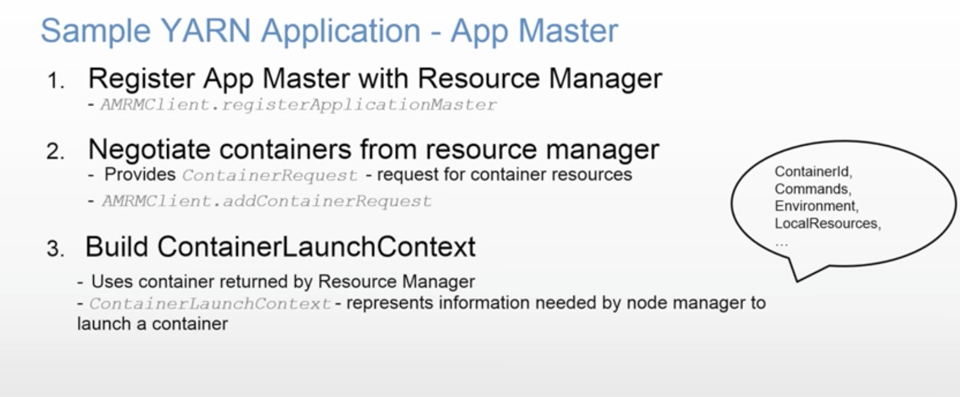

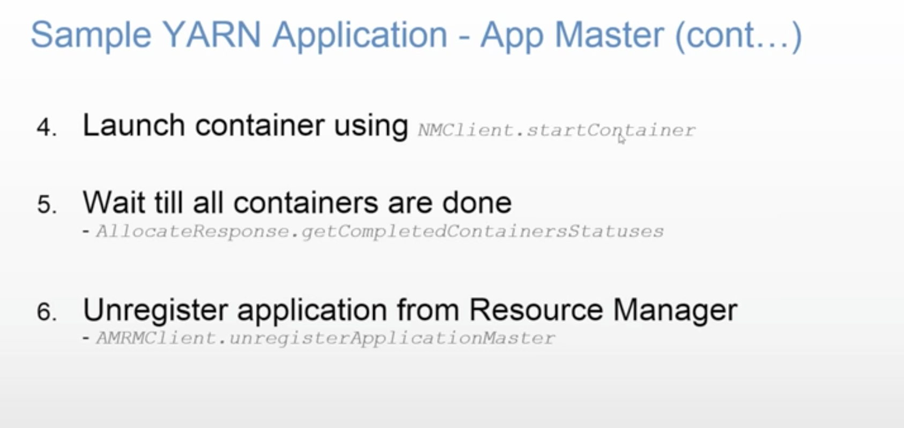

You might have a need where two containers needs to share data. You can configure locality of the containers to be on the same node, so that they don’t use much network. Ideally, you should write independent applications.

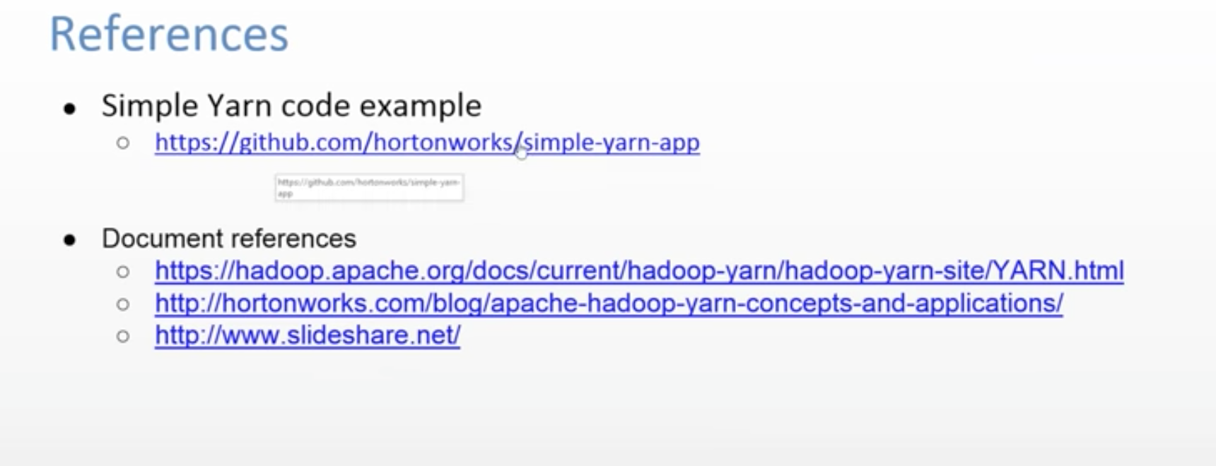



Failures **(pg 193 of book)**

## RM Failure

You can have **Stand By RM**. So, if primary RM fails, then Stand By RM is promoted as primary RM.

Information about all the running applications is stored in a highly available state store **(backed by** ZooKeeper **or HDFS)**, so that the standby can recover the core state of the failed active resource manager. Node manager information is not stored in the state store since it can be reconstructed relatively quickly by the new resource manager as the node managers send their first heartbeats.

How does it handle long running jobs?

Jobs can be run for months long. Hadoop takes care of failure of nodes.

How Application Master is started?

RM can launch it on any available Node based on its availability.

## Task Failure

Consider first the case of the task failing. The most common occurrence of this failure is when user code in the **map or reduce task throws a runtime exception**. If this happens, the task JVM reports the error back to its parent application master before it exits. The error ultimately makes it into the user logs. The application master marks the task **attempt as *failed***, and frees up the container so its resources are available for another task.

For Streaming tasks, if the Streaming process exits with a nonzero exit code, it is marked as failed. This behavior is governed by the stream.non.zero.exit.is.failure property (the default is true).

Another failure mode is the sudden exit of the task JVM—perhaps there is a JVM bug that causes the JVM to exit for a particular set of circumstances exposed by the MapReduce user code. In this case, the node manager notices that the process has exited and informs the application master so it can mark the attempt as failed.

Hanging tasks are dealt with differently. The application master notices that it hasn’t received a progress update for a while and proceeds to mark the task as failed. The task JVM process will be killed automatically after this period.3 The **timeout period** after which tasks are considered failed is **normally 10 minutes and can be configured on a per-job basis (or a cluster basis)** by setting the **mapreduce.task.timeout** property to a value in milliseconds.

Setting the timeout to a value of zero disables the timeout, so long-running tasks are never marked as failed. In this case, a hanging task will never free up its container, and over time there may be cluster slowdown as a result. This approach should therefore be avoided, and making sure that a task is reporting progress periodically should suffice

When the application master is notified of a task attempt that has failed, it will **reschedule** execution of the task.

**The application master will try to avoid rescheduling the task on a node manager where it has previously failed.** Furthermore, if a task fails four times, it will not be retried again. This value is configurable. The maximum number of attempts to run a task is controlled by the **mapreduce.map.maxattempts** property for map tasks and **mapreduce.reduce.maxattempts** for reduce tasks. **By default, if any task fails four times (or whatever the maximum number of attempts is configured to), the whole job fails.**

**A task attempt may also be *killed*, which is different from it failing.** A task attempt may be killed because it is a speculative duplicate or because the node manager it was running on failed and the application master marked all the task attempts running on it as killed. Killed task attempts do not count against the number of attempts to run the task (as set by mapreduce.map.maxattempts and mapreduce.reduce.maxattempts), because it wasn’t the task’s fault that an attempt was killed.

**Users may also kill or fail task attempts using the web UI or the command line** (type mapred job to see the options). Jobs may be killed by the same mechanisms.

## Application Master Failure

Just like MapReduce tasks are given several attempts to succeed (in the face of hardware or network failures), applications in YARN are retried in the event of failure. The maximum number of attempts to run a MapReduce application master is controlled by the **mapreduce.am.max-attempts** property. The default value is 2, so if a MapReduce application master fails twice it will not be tried again and the job will fail.

YARN imposes a limit for the maximum number of attempts for any YARN application master running on the cluster, and individual applications may not exceed this limit. The limit is set by **yarn.resourcemanager.am.max-attempts** and **defaults to 2**, so if you want to increase the number of MapReduce application master attempts, you will have to increase the YARN setting on the cluster, too.

The way recovery works is as follows. An application master sends periodic heartbeats to the resource manager, and in the event of application master failure, the resource manager will detect the failure and start a new instance of the master running in a new container (managed by a node manager). In the case of the MapReduce application master, it will use the job history to recover the state of the tasks that were already run by the (failed) application so they don’t have to be rerun. Recovery is enabled by default, but can be disabled by setting **yarn.app.mapreduce.am.job.recovery.enable** to false.

The MapReduce client polls the application master for progress reports, but if its application master fails, the client needs to locate the new instance. During job initialization, the client asks the resource manager for the application master’s address, and then caches it so it doesn’t overload the resource manager with a request every time it needs to poll the application master. If the application master fails, however, the client will experience a timeout when it issues a status update, at which point the client will go back to the resource manager to ask for the new application master’s address. This process is transparent to the user.

## Node Manager Failure

If a node manager fails by crashing or running very slowly, **it will stop sending heartbeats to the resource manage**r (or send them very infrequently). The resource manager will notice a node manager that has stopped sending heartbeats if it hasn’t received one for **10 minutes** (this is configured, in milliseconds, via the **yarn.resourcemanager.nm.liveness-monitor.expiry-interval-ms** property) and remove it from its pool of nodes to schedule containers on.

Any task or application master running on the failed node manager will be recovered using the mechanisms described in the previous two sections. In addition, the application master arranges for map tasks that were run and completed successfully on the failed node manager to be rerun if they belong to incomplete jobs, since their inter‐ mediate output residing on the failed node manager’s local filesystem may not be accessible to the reduce task.

**Node managers may be *blacklisted* if the number of failures for the application is high**, even if the node manager itself has not failed. Blacklisting is done by the application master, and for MapReduce the application master will try to reschedule tasks on different nodes if more than three tasks fail on a node manager. The user may set the threshold with the **mapreduce.job.maxtaskfailures.per.tracker** job property.

## Resource Manager Failure

Failure of the resource manager is serious, because without it, neither jobs nor task containers can be launched. In the default configuration, the resource manager is a single point of failure, since in the (unlikely) event of machine failure, all running jobs fail—and can’t be recovered.

To achieve high availability (HA), it is necessary to run a pair of resource managers in an active-standby configuration. If the active resource manager fails, then the standby can take over without a significant interruption to the client.

Information about all the running applications is stored in a highly available state store (**backed by ZooKeeper or HDFS**), so that the standby can recover the core state of the failed active resource manager. **Node manager information is not stored in the state store since it can be reconstructed relatively quickly by the new resource manager as the node managers send their first heartbeats.** (Note also that tasks are not part of the resource manager’s state, since they are managed by the application master. Thus, the amount of state to be stored is therefore much more manageable than that of the job‐ tracker in MapReduce 1.)

When the new resource manager starts, it reads the application information from the state store, then restarts the application masters for all the applications running on the cluster. This does not count as a failed application attempt (so it does not count against **yarn.resourcemanager.am.max-attempts**), since the application did not fail due to an error in the application code, but was forcibly killed by the system. In practice, the application master restart is not an issue for MapReduce applications since they recover the work done by completed tasks

The transition of a resource manager from standby to active is handled by a failover controller. The default failover controller is an automatic one, which uses ZooKeeper leader election to ensure that there is only a single active resource manager at one time.

**Clients and node managers must be configured to handle resource manager failover, since there are now two possible resource managers to communicate with. They try connecting to each resource manager in a round-robin fashion until they find the active one. If the active fails, then they will retry until the standby becomes active.**

# MapReduce Flow

(pg 197 of the book)

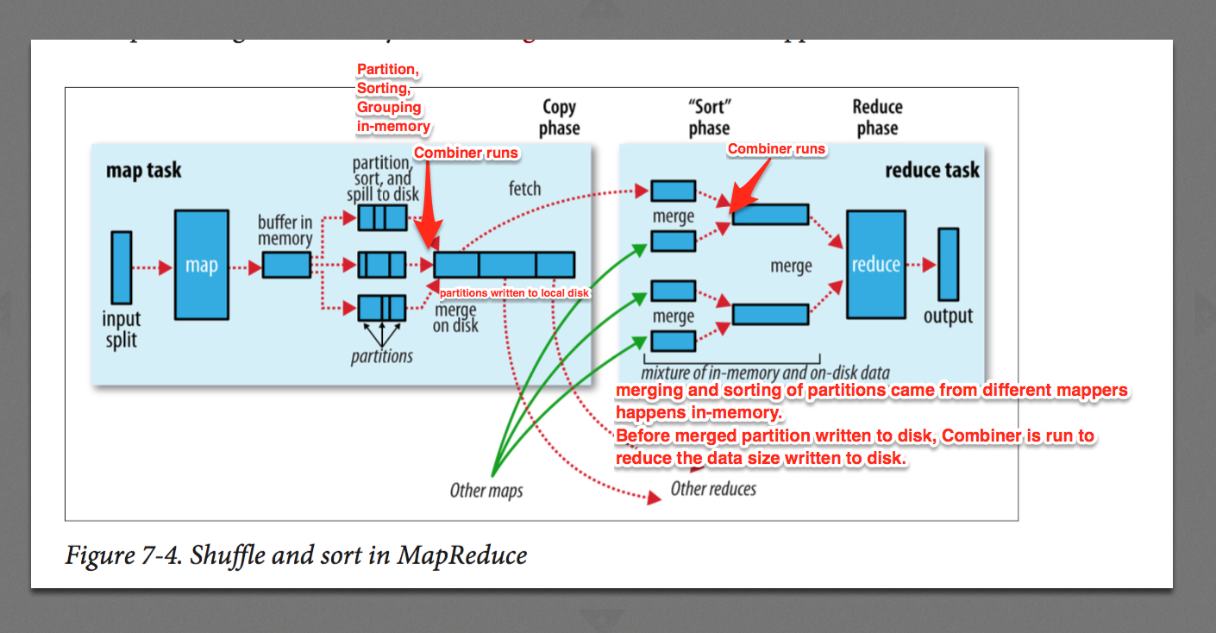

e.g. input to Mapper is a block of data that has year and temperature information

*(0, 0067011990999991950051507004...9999999N9+00001+99999999999...)  
 (106, 0043011990999991950051512004...9999999N9+00221+99999999999...)  
 (212, 0043011990999991950051518004...9999999N9-00111+99999999999...)  
 (318, 0043012650999991949032412004...0500001N9+01111+99999999999...)  
  
Output of Mapper  
 year-temperature pairs  
  
 (1950, 0)  
 (1950, 22)  
 (1950, −11)  
 (1949, 111)  
 (1949, 78)*

*partitioned, sorted, grouped, (optionally combined – if combiner is specified) year-temperature pairs  
  
 (1949, [111, 78])  
 (1950, [0, 22, −11])*

Output from Reducer (max temperature for a year)

Before data is input to Reducer, partitions came from Mappers are merged, sorted, grouped, (optionally combined) before writing to Reducer’s local disk and then feeding it to Reducer.

(1949, 111)

(1950, 22)

## Mapper

Before mapper outputs the data, many processes happen on it. That is called Shuffling.

Every mapper has limited memory to hold the output. When this buffer is full, output has to be spilled over to disk. Before it is spilled over to disk, they are partitioned as per number of reducers. Data in each partition is sorted and grouped. Before writing this partitions to disk, **Combiner is run to reduce the amount of data to be written to local disk**, if Combiner code is provided. This also reduces the data to be sent over the network to Reducer.

Each time the memory buffer reaches the spill threshold, a new spill file is created, so after the map task has written its last output record, there could be several spill files, which are partitioned, sorted and grouped. Before the task is finished, the spill files are merged into a single partitioned and sorted output file.

## Reducer

In Copy Phase, final output from all mappers are transferred to Reducer via HTTP (Network). The reduce task has a small number of copier threads so that it can fetch map outputs in parallel.

Mapping phase’s output (partitions) are first copied in Reducer’s memory. Where they are merged, sorted and grouped. Before spilling them to disk, Combiner is run again to reduce input data size to Reducer.

Likewise, many partitions are merged for each reducer and written to disk. Background thread will keep merging, sorting, grouping these disk written data.

Finally, when all partitions came from all mappers are merged, they are given as input to Reducer.

During the reduce phase, the reduce function is invoked for each key in the sorted output. The output of this phase is written directly to the output filesystem, typically HDFS.

Remember:

output of Mapper is written to Local Disk and output of Reducer is written to HDFS because it is more important to save later one properly because that’s the final output and earlier one is an intermittent output.

If there is no reducer, then the output of mappers becomes final output and they will be written to HDFS.

NOTE: my earlier assumption was that Combiner runs on mapper side, but that was wrong. It runs on both mapper and reducer side.

For the entire Map and Reduce phase, there are many configured parameters used during shuffling and reducing process. You can read those parameters from book.

# Number of mappers?

I explicitly specify the number of mappers within my java program using conf.setNumMapTasks(), but when the job ends, the counter shows that the number of launched map tasks were more than the specified value. How to limit the number of mapper to the specified value?

mapred.map.tasks parameter or conf.setNumMapTasks() is just a hint to the InputFormat for number of mappers. **Number of mappers is decided by the number of Input Split**s created by hadoop for your given set of inputs**. You may control this by setting mapred.min.split.size parameter to control number of Input Splits and so number of Mappers.**

# How to choose number of reducers?

(pg 217 of the book)

Choosing the number of reducers for a job is more of an art than a science. Increasing the number of reducers makes the reduce phase shorter, since you get more parallelism. However, if you take this too far, you can have lots of small files, which is suboptimal.

One rule of thumb is to aim for reducers that each run for five minutes or so, and which produce at least one HDFS block’s worth of output.

# MapReduce Tuning

(pg 201 of the book)

The general principle is to give the shuffle as much memory as possible. However, there is a trade-off, in that you need to make sure that your map and reduce functions get enough memory to operate. This is why it is best to write your map and reduce functions to use as little memory as possible—certainly they should not use an unbounded amount of memory

On the map side, the best performance can be obtained by avoiding multiple spills to disk; one is optimal. If you can estimate the size of your map outputs, you can set the mapreduce.task.io.sort.* properties appropriately to minimize the number of spills. In particular, you should increase mapreduce.task.io.sort.mb if you can. There is a MapReduce counter (SPILLED_RECORDS) that counts the total number of records that were spilled to disk over the course of a job, which can be useful for tuning. Note that the counter includes both map- and reduce-side spills.

On the reduce side, the best performance is obtained when the intermediate data can reside entirely in memory. This does not happen by default, since for the general case all the memory is reserved for the reduce function. But if your reduce function has light memory requirements, setting mapreduce.reduce.merge.inmem.threshold to 0 and mapreduce.reduce.input.buffer.percent to 1.0 (or a lower value) may bring a performance boost.

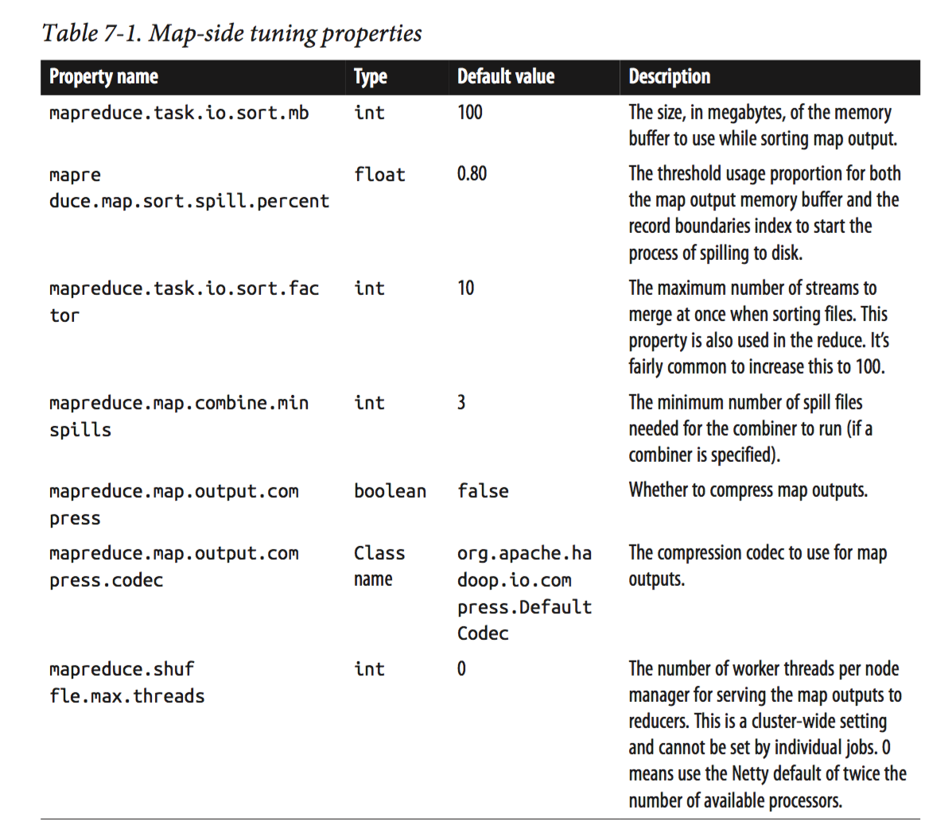

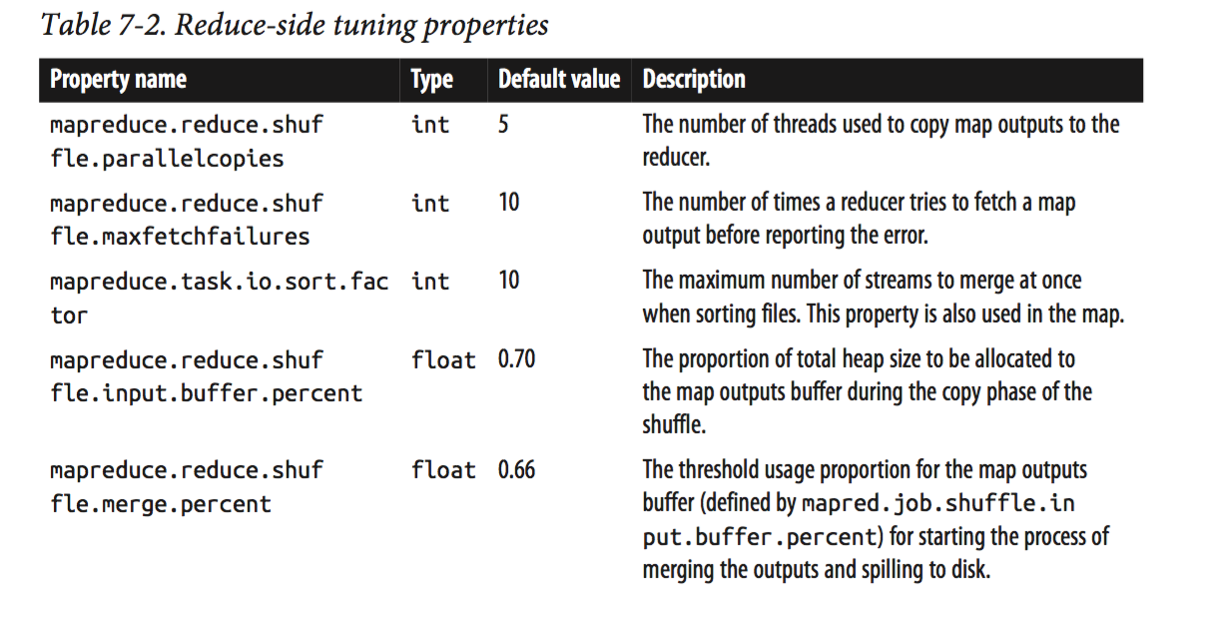

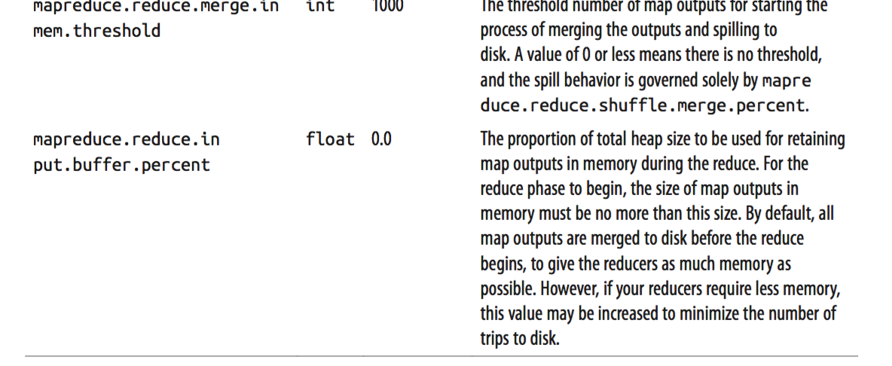

You can access task related information using below properties

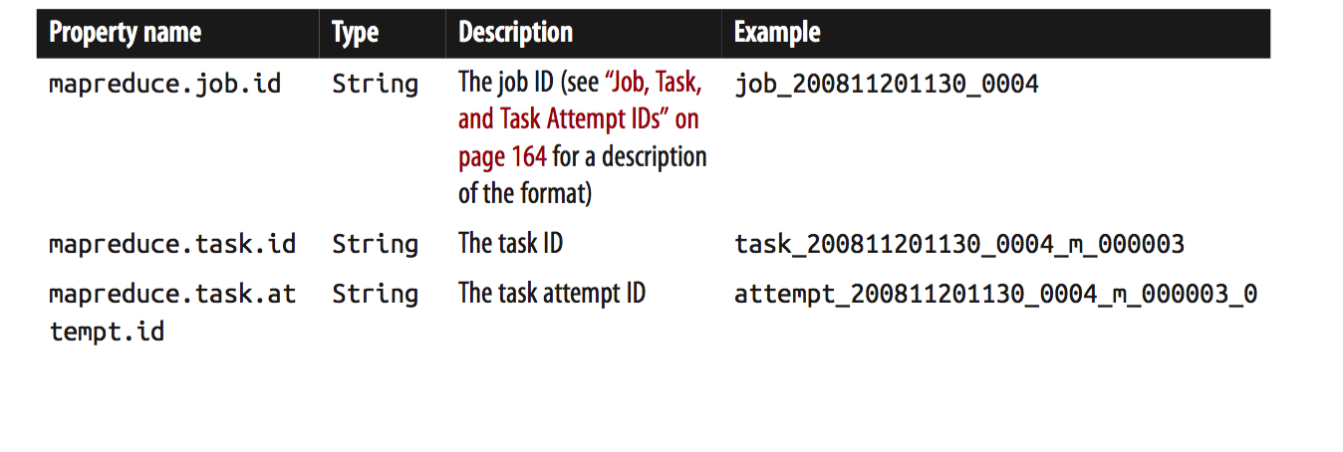

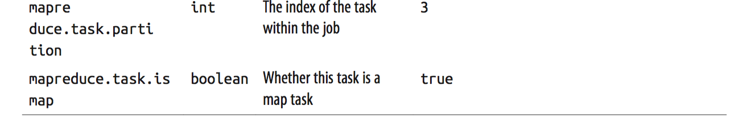

# Speculative Execution of Task

When a job consists of hundreds or thousands of tasks, the possibility of a few straggling tasks is very real.

Tasks may be slow for various reasons, including hardware degradation or software misconfiguration, but the causes may be hard to detect because the tasks still complete successfully, albeit after a longer time than expected. Hadoop doesn’t try to diagnose and fix slow-running tasks; instead, it tries to detect when a task is running slower than expected and launches another equivalent task as a backup. This is termed ***speculative execution* of tasks**.

It’s important to understand that speculative execution does not work by launching two duplicate tasks at about the same time so they can race each other. This would be wasteful of cluster resources.

When a task completes successfully, any duplicate tasks that are running are killed since they are no longer needed. So, if the original task completes before the speculative task, the speculative task is killed; on the other hand, if the speculative task finishes first, the original is killed.

Speculative execution is turned on by default. It can be enabled or disabled independently for map tasks and reduce tasks, on a cluster-wide basis, or on a per-job basis.

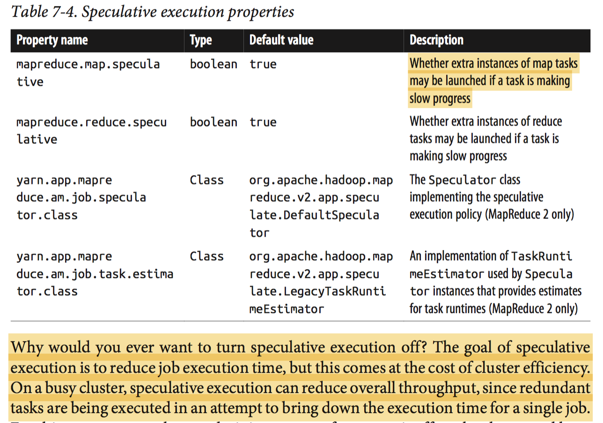

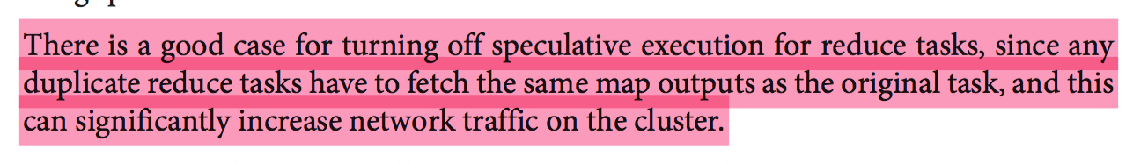

# What is Output Committers?

Output Committer takes care of processes that needs to be done on success/failure of a job.

Hadoop MapReduce uses a commit protocol to ensure that jobs and tasks either succeed or fail cleanly.

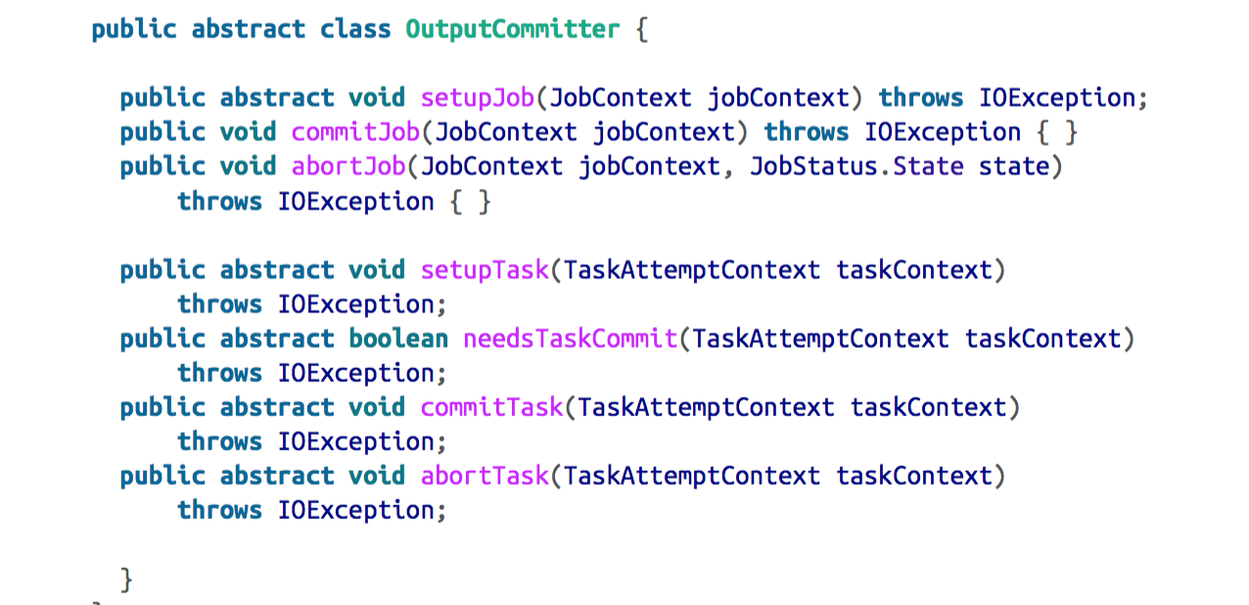

The setupJob() method is called before the job is run, and is typically used to perform initialization. For FileOutputCommitter, the method creates the final output directory, ${mapreduce.output.fileoutputformat.outputdir}, and a temporary working space for task output, *_temporary*, as a subdirectory underneath it.

If the job succeeds, the commitJob() method is called, which in the default file-based implementation deletes the temporary working space and creates a hidden empty marker file in the output directory called *_SUCCESS* to indicate to filesystem clients that the job completed successfully. If the job did not succeed, abortJob() is called with a state object indicating whether the job failed or was killed (by a user, for example). In the default implementation, this will delete the job’s temporary working space.

The operations are similar at the task level. The setupTask() method is called before the task is run, and the default implementation doesn’t do anything, because temporary directories named for task outputs are created when the task outputs are written.

The commit phase for tasks is optional and may be disabled by returning false from needsTaskCommit(). This saves the framework from having to run the distributed commit protocol for the task, and neither commitTask() nor abortTask() is called. FileOutputCommitter will skip the commit phase when no output has been written by a task.

If a task succeeds, commitTask() is called, which in the default implementation moves the temporary task output directory (which has the task attempt ID in its name to avoid conflicts between task attempts) to the final output path, ${mapreduce.output.fileoutputformat.outputdir}. Otherwise, the framework calls abortTask(), which deletes the temporary task output directory.

# Task side-effect files

Care needs to be taken to ensure that multiple instances of the same task don’t try to write to the same file. As we saw in the previous section, the OutputCommitter protocol solves this problem. If applications write side files in their tasks’ working directories, the side files for tasks that successfully complete will be promoted to the output directory automatically, whereas failed tasks will have their side files deleted.

# MapReduce Input Formats

There are 3 main components involved to feed key-value pair to mapper.  
- InputSplit  
- InputFormat  
- RecordReader  
and  
- Context that holds RecordReader

InputSplit (it doesn’t contain actual splits. It has only locations of blocks in hdfs)

String[] getLocations()

Long getLength()

InputFormat (provides inputsplits and RecordReader required to create input key-value for mapper)

**InputSplit**[]

**RecordReader**<k,v> (reads data from DataInputStream and converts it into key-valu for input of mapper)

boolean next(key,value)

k createKey()

v createValue()

long getPos()

void close()

float getProgress()

OutputFormat

**RecordWriter**<k,v> (writes O/p of mapper and reducer to DataOutputStream)

void write(k,v)

void close()

Key and Value are of type Writable. Every Writable has to be Comparable. So, it implements WritableComparable. They have compareTo() method that is used for sorting and grouping unless custom Comparator is provided for them. You can set custom Comparator(s) for sorting and grouping in job in client (driver) class. You will see an example in ‘Secondary Sort’ section.

Writable (You can have custom Writable also. You will see example in ‘secondary sort’ section.)

|

WritableComparable

| voidwrite(DataOutput out)

| void readFields(DataInput in)

|

| | | |

Text IntWritable LongWritable …..

InputFormat

|

| | |

FileInputFormat CompositeInputFormat DBInputFormat

|

| | | | |

TextInputFormat CombineFileInputFormat KeyValueTextInputFormat NLineInputFormat SequenceFileInputFormat

|

--------------------------------------------------------------------------------

| | |

SequenceFileAsBinaryInputFormat SeqFileAsTextInputFormat SequenceFileInputFilter

Context objects for Mapper and Reducer classes

TaskInputOutputContextImpl

|

---------------------------------------------------------------------------------------------

| |

MapContext ReduceContext

InputSplit Key

RecordReader Value

RecordWriter KeyDeserializer

OutputCommitter ValueDeserializer

StatusReporter ValueIterator

RawComparator<key>

Partitioner (provides partition number based on key data)(you can create custom partitioner also. You will see example in ‘secondary sort’ section)

|

| | |

HashPartitioner BinaryPartitioner …

Comparator (used for sorting and grouping of mapper’s output before giving it to reducer as input)(you can have custom comparator also. You will see example in ‘secondary sort’ section)

|

RawComparator

|

ByteArrayComparator

InputFormat is responsible to create InputSplit and RecordReader.

e.g. FileInputFormat

You provide path(s) of file(s)/directory from which splits needs to be created based on split size related configuration parameter.  
  
FileInputFormat is responsible to create InputSplits.  
  
Who asks FileInputFormat to create InputSplits?  
 JobSubmitter class  
Who calls JobSubmitter?  
 Client

So, Client actually creates InputSplits with the help of FileInputFormat and that information is stored in HDFS. Later on, Application Master will use this information to know how many tasks needs to be created.

What is InputSplit?  
 HDFS blocks are of size 128MB by default. It is possible that last record in a block is finishing in some other block.  
 In this case, InputSplit will contain 2 blocks location information and size of a split will be little more than 128MB.  
  
What is RecordReader?  
  
RecordReader creates key-value pair from InputSplit and gives it to Mapper. Mapper accesses RecordReader using Context.

## What is InputSplit?

(pg. 233 of book)

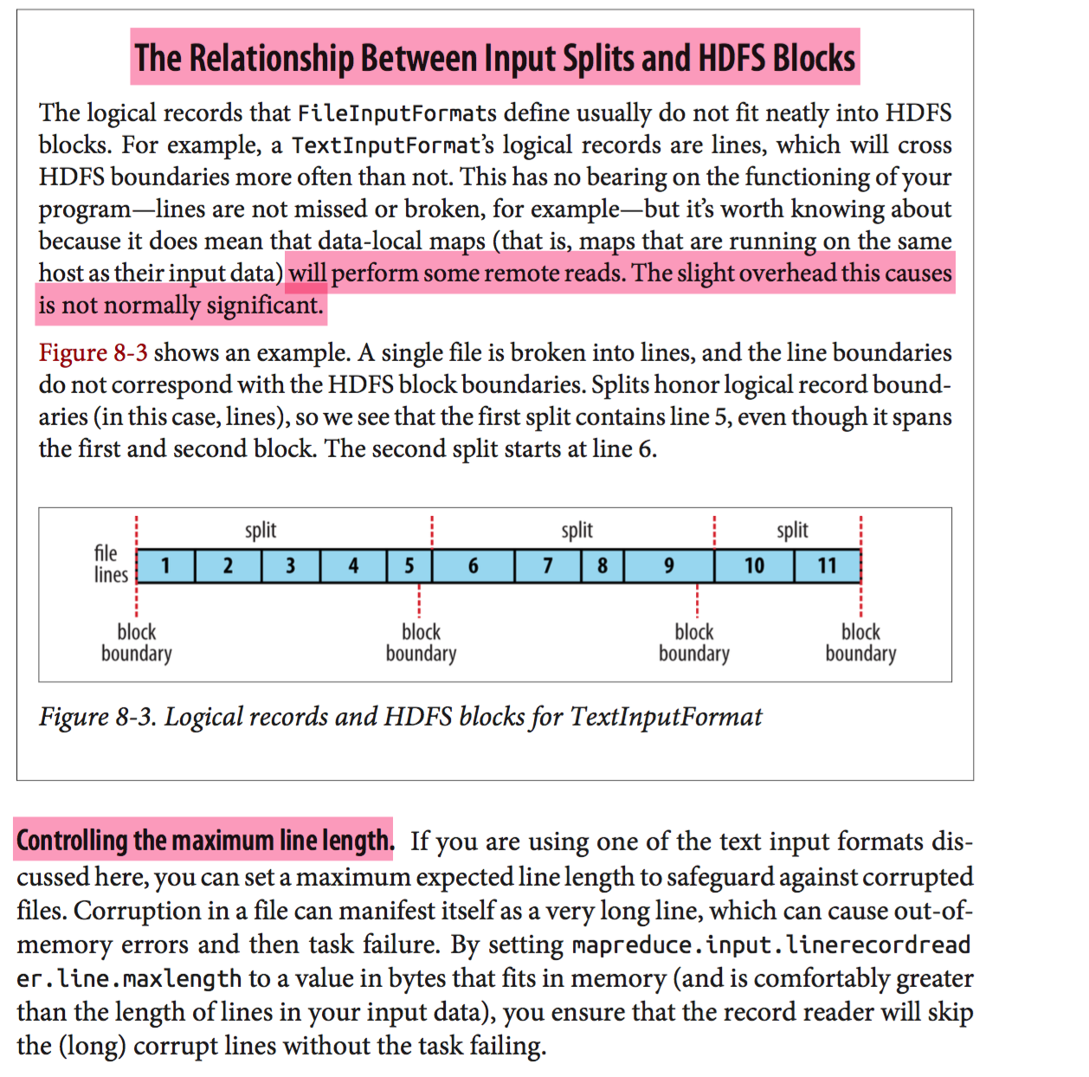

<http://www.dummies.com/programming/big-data/hadoop/input-splits-in-hadoops-mapreduce/>

If each map task processes all records in a specific data block, what happens to those records that span block boundaries? File blocks are exactly 64MB (or whatever you set the block size to be), and because HDFS has no conception of what’s inside the file blocks, it can’t gauge when a record might spill over into another block.

To solve this problem, Hadoop uses a logical representation of the data stored in file blocks, known as input splits. When a MapReduce job client calculates the input splits, it figures out where the first whole record in a block begins and where the last record in the block ends.

In cases where the last record in a block is incomplete, the input split includes location information for the next block and the byte offset of the data needed to complete the record.

The figure shows this relationship between data blocks and input splits.

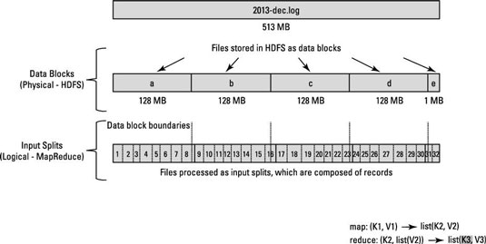

MapReduce data processing is driven by this concept of input splits. The number of input splits that are calculated for a specific application determines the number of mapper tasks. Each of these mapper tasks is assigned, where possible, to a slave node where the input split is stored. The Resource Manager (or JobTracker, if you’re in Hadoop 1) does its best to ensure that input splits are processed locally.

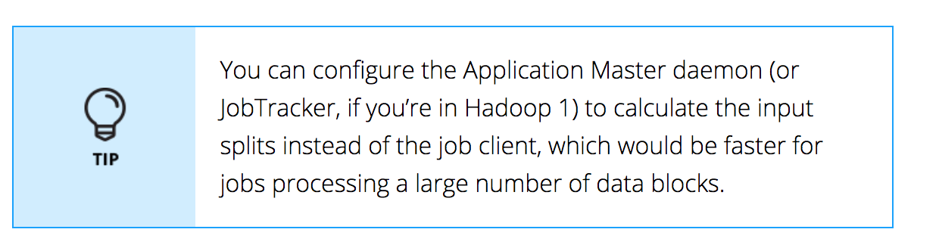

**MapReduce** data processing is driven by this concept of **input splits**. The number of input splits that are calculated for a specific application determines the number of mapper tasks.

The number of maps is usually driven by the number of DFS blocks in the input files.

Each of these mapper tasks is assigned, where possible, to a slave node where the input split is stored. The Resource Manager (or JobTracker, if you’re in Hadoop 1) does its best to ensure that input splits are processed locally.

If ***data locality*** can't be achieved due to input splits crossing boundaries of data nodes, some data will be transferred from one Data node to other Data node.

Input splits are represented by the Java class InputSplit (which, like all of the classes mentioned in this section, is in the org.apache.hadoop.mapreduce package)

public abstract class InputSplit {

public abstract long getLength() throws IOException, InterruptedException;

public abstract String[] getLocations() throws IOException, InterruptedException;

}

An InputSplit has a length in bytes and a set of storage locations, which are just host‐ name strings. **Notice that a split doesn’t contain the input data; it is just a reference to the data**. The storage locations are used by the MapReduce system to place map tasks as close to the split’s data as possible, and the size is used to order the splits so that the largest get processed first, in an attempt to minimize the job runtime (this is an instance of a greedy approximation algorithm).

As a MapReduce application writer, you don’t need to deal with InputSplits directly, as they are created by an InputFormat (an InputFormat is responsible for creating the input splits and dividing them into records).

## InputFormat and RecordReader

public abstract class InputFormat<K, V> {

public abstract List<InputSplit> getSplits(JobContext context) throws IOException, InterruptedException;

public abstract RecordReader<K, V> createRecordReader(InputSplit split, TaskAttemptContext context) throws IOException, InterruptedException;

}

**A RecordReader is little more than an iterator over records, and the map task uses one to generate record key-value pairs, which it passes to the map function.**

We can see this by looking at the Mapper’s run() method:

**public void** run(Context context) **throws** IOException, InterruptedException {

setup(context);

**while** (context.nextKeyValue()) {

map(context.getCurrentKey(), context.getCurrentValue(), context);

}

cleanup(context);

}

After running setup(), the nextKeyValue() is called repeatedly on the Context (which delegates to the identically named method on the RecordReader) to populate the key and value objects for the mapper. The key and value are retrieved from the RecordReader by way of the Context and are passed to the map() method for it to do its work. When the reader gets to the end of the stream, the nextKeyValue() method returns false, and the map task runs its cleanup() method and then completes.

**Finally, note that the Mapper’s run() method is public and may be customized by users.**

### Preventing splitting

(pg 227 of book)

How to force Not to create more than 1 split?  
  
Some applications don’t want files to be split, as this allows a single mapper to process each input file in its entirety. For example, a simple way to check if all the records in a file are sorted is to go through the records in order, checking whether each record is not less than the preceding one. Implemented as a map task, this algorithm will work only if one map processes the whole file.

There are a couple of ways to ensure that an existing file is not split. The first (quick- and-dirty) way is to increase the minimum split size to be larger than the largest file in your system. Setting it to its maximum value, Long.MAX_VALUE, has this effect. The second is to subclass the concrete subclass of FileInputFormat that you want to use, to override the isSplitable() method3 to return false. For example, here’s a nonsplittable TextInputFormat:  
  
 import org.apache.hadoop.fs.Path;  
 import org.apache.hadoop.mapreduce.JobContext;  
 import org.apache.hadoop.mapreduce.lib.input.TextInputFormat;  
 public class NonSplittableTextInputFormat extends TextInputFormat {  
 @Override  
 protected boolean isSplitable(JobContext context, **Path file**) {  
 return false; *---- This will create one split per file. If you have input multiple files. There will be that many splits. At least, it won’t create more than one split for a file.* }  
 }

**This should be avoided. There is no point of using Hadoop, if you are not going to have multiple mappers. You are not taking advantage of Hadoop’s parallel processing.**

You can see an example in a book for how to create an InputFormat that creates only one split per file and how to create RecordReader that ignores a key and reads entire split given to it in byte format. You can create a Mapper that gets null key and entire file in byte format from RecordReader and creates output key-value pair with filename-filecontent.

## InputFormat Class Hierarchy

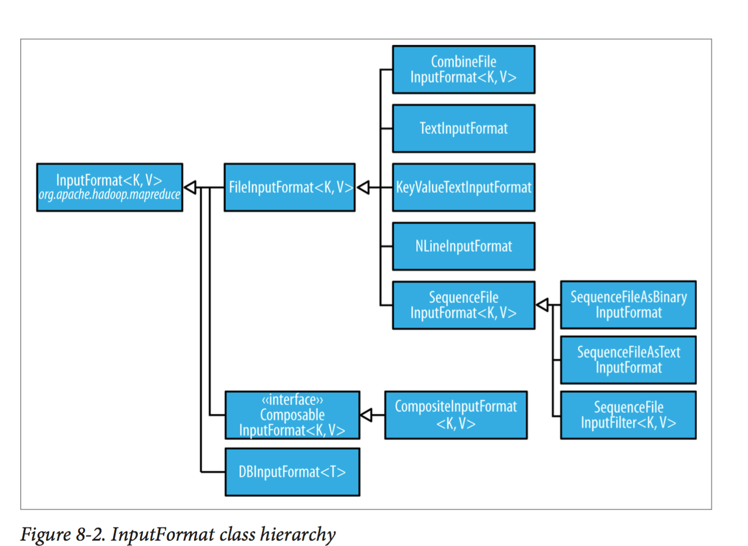

### FileInputFormat

Given a set of files, how does FileInputFormat turn them into splits? FileInputFormat splits only large files—here, “large” means larger than an HDFS block. The split size is normally the size of an HDFS block, which is appropriate for most applications; however, it is possible to control this value by setting various Hadoop properties,

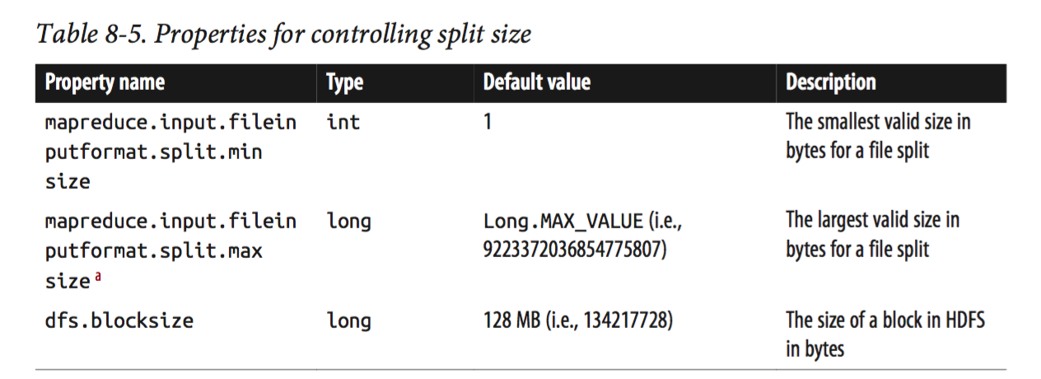

Applications may impose a minimum split size. By setting this to a value larger than the block size, they can force splits to be larger than a block. There is no good reason for doing this when using HDFS, because doing so will increase the number of blocks that are not local to a map task.

The maximum split size defaults to the maximum value that can be represented by a Java long type. It has an effect only when it is less than the block size, forcing splits to be smaller than a block.

#### CombineFileInputFormat

**Hadoop works better with a small number of large files than a large number of small files.**

One reason for this is that FileInputFormat generates splits in such a way that each split is all or part of a single file. If the file is very small (“small” means significantly smaller than an HDFS block) and there are a lot of them, each map task will process very little input, and there will be a lot of them (one per file), each of which imposes extra bookkeeping overhead. Compare a 1 GB file broken into eight 128 MB blocks with 10,000 or so 100 KB files. The 10,000 files use one map each, and the job time can be tens or hundreds of times slower than the equivalent one with a single input file and eight map tasks.

**Where FileInputFormat creates a split per file, CombineFileInputFormat packs many files into each split so that each mapper has more to process. Crucially, CombineFileInputFormat takes node and rack locality into ac‐ count when deciding which blocks to place in the same split, so it does not compromise the speed at which it can process the input in a typical MapReduce job.**

Of course, if possible, it is still a good idea to avoid the many small files case, because MapReduce works best when it can operate at the transfer rate of the disks in the cluster, and processing many small files increases the number of seeks that are needed to run a job. Also, storing large numbers of small files in HDFS is wasteful of the namenode’s memory.

#### Text Input

##### TextInputFormat

TextInputFormat is the default InputFormat. Each record is a line of input. The key, a LongWritable, is the byte offset within the file of the beginning of the line. The value is the contents of the line

On the top of the Crumpetty Tree

The Quangle Wangle sat,

But his face you could not see,

On account of his Beaver Hat.

is divided into one split of four records. The records are interpreted as the following key-value pairs:

(0, On the top of the Crumpetty Tree)

(33, The Quangle Wangle sat,)

(57, But his face you could not see,)

(89, On account of his Beaver Hat.)

Clearly, the keys are *not* line numbers.

###### KeyValueTextInputFormat

TextInputFormat’s keys, being simply the offsets within the file, are not normally very useful. It is common for each line in a file to be a key-value pair, separated by a delimiter such as a tab character.

You can specify the separator via the mapreduce.input.keyvaluelinere cordreader.key.value.separator property. It is a tab character by default.

line1→On the top of the Crumpetty Tree

line2→The Quangle Wangle sat,

line3→But his face you could not see,

line4→On account of his Beaver Hat.

Like in the TextInputFormat case, the input is in a single split comprising four records, although this time the keys are the Text sequences before the tab in each line:

(line1, On the top of the Crumpetty Tree)

(line2, The Quangle Wangle sat,)

(line3, But his face you could not see,)

(line4, On account of his Beaver Hat.)

#### NLineInputFormat

If you want your mappers to receive a fixed number of lines of input, then NLineInputFormat is the InputFormat to use.

By way of example, con‐ sider these four lines again:

On the top of the Crumpetty Tree

The Quangle Wangle sat,

But his face you could not see,

On account of his Beaver Hat.

If, for example, *N* is 2, then each split contains two lines. One mapper will receive the first two key-value pairs:

(0, On the top of the Crumpetty Tree)

(33, The Quangle Wangle sat,)

And another mapper will receive the second two key-value pairs:

(57, But his face you could not see,)

(89, On account of his Beaver Hat.)

The keys and values are the same as those that TextInputFormat produces. The difference is in the way the splits are constructed.

**Usually, having a map task for a small number of lines of input is inefficient (due to the overhead in task setup), but there are applications that take a small amount of input data and run an extensive (i.e., CPU-intensive) computation for it, then emit their output.**

##### Processing XML File

Large XML documents that are composed of a series of “records” (XML document fragments) can be broken into these records using simple string or regular-expression matching to find the start and end tags of records. This alleviates the problem when the document is split by the framework because the next start tag of a record is easy to find by simply scanning from the start of the split, just like TextInputFormat finds newline boundaries.

Hadoop comes with a class for this purpose called **StreamXmlRecordReader** (which is in the org.apache.hadoop.streaming.mapreduce package, although it can be used outside of Streaming). You can use it by setting your input format to **StreamInputFormat** and setting the stream.recordreader.class property to org.apache.ha doop.streaming.mapreduce.StreamXmlRecordReader.

Using StreamXmlRecordReader, the page elements can be interpreted as records for processing by a mapper.

##### 

#### Binary Input

##### SequenceFileInputFormat

Below example shows the example of SequenceFileInputFormat and SequenceFileOutputFormat.

<https://examples.javacodegeeks.com/enterprise-java/apache-hadoop/hadoop-sequence-file-example/>

Input file is a text file that can be read as key-value. So, using KeyValueTextInputFormat, Mapper is fed input records. Output is controlled using SequenceFileOutputFormat that creates output of the job in binary form. **This Binary form of output file can be used as an input to another job**. Another application can read this binary file using SequenceFileInputFormat and use TextOutputFormat to create a text file.

This is a good choice of output if it forms the input to a further MapReduce job, since it is compact and is readily compressed.

Advantages of Sequence Files (Binary files)

* It requires less space than text files
* It provides compression algorithms using which you can compress sequence files for better usage of the space.

Sequence files can be compressed for space considerations and based on these compression type users, Hadoop Sequence files can be of three types:

1. Uncompressed
2. Record Compressed
3. Block Compressed

There is a specific format in which Sequence Files are created. You can see that format in above mentioned example.

Text file

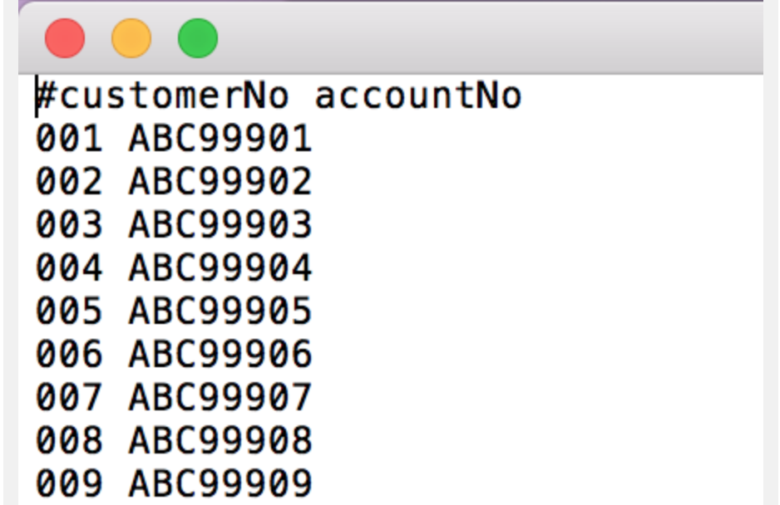

Sequence File (Binary file)

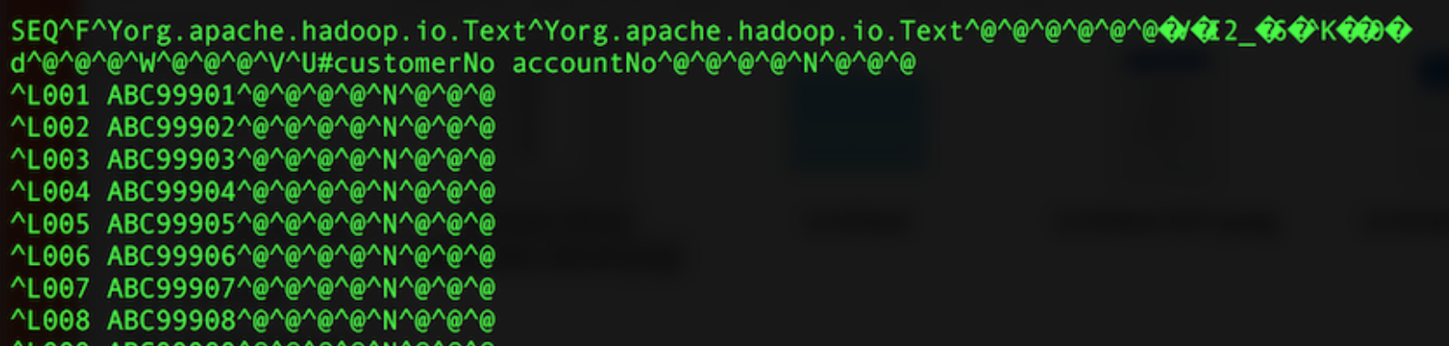

This sequence file can be read using SequenceFileInputFormat. It will use SequenceFileRecordReader to feed these binary key-value to mapper.

If you want to convert these binary key-value into text, then use SequenceFileTextInputFormat.

<http://blog.cloudera.com/blog/2011/01/hadoop-io-sequence-map-set-array-bloommap-files/>



###### SequenceFileAsTextInputFormat

SequenceFileAsTextInputFormat is a variant of SequenceFileInputFormat that converts the sequence file’s keys and values to Text objects. The conversion is performed by calling toString() on the keys and values.

###### SequenceFileAsBinaryInputFormat

SequenceFileAsBinaryInputFormat is a variant of SequenceFileInputFormat that retrieves the sequence file’s keys and values as opaque binary objects. They are encapsulated as BytesWritable objects

###### FixedLengthInputFormat

FixedLengthInputFormat is for reading fixed-width binary records from a file, when the records are not separated by delimiters. The record size must be set via fixed lengthinputformat.record.length.

### Database Input/Output Format

DBInputFormat is an input format for reading data from a relational database, using JDBC. **Because it doesn’t have any sharding capabilities, you need to be careful not to overwhelm the database from which you are reading by running too many mappers.**

For this reason, it is best used for loading relatively small datasets, perhaps for joining with larger datasets from HDFS using MultipleInputs. The corresponding output format is DBOutputFormat, which is useful for dumping job outputs (of modest size) into a database.

For an alternative way of moving data between relational databases and HDFS, consider using Sqoop.

## OutputFormat Class Hierarchy

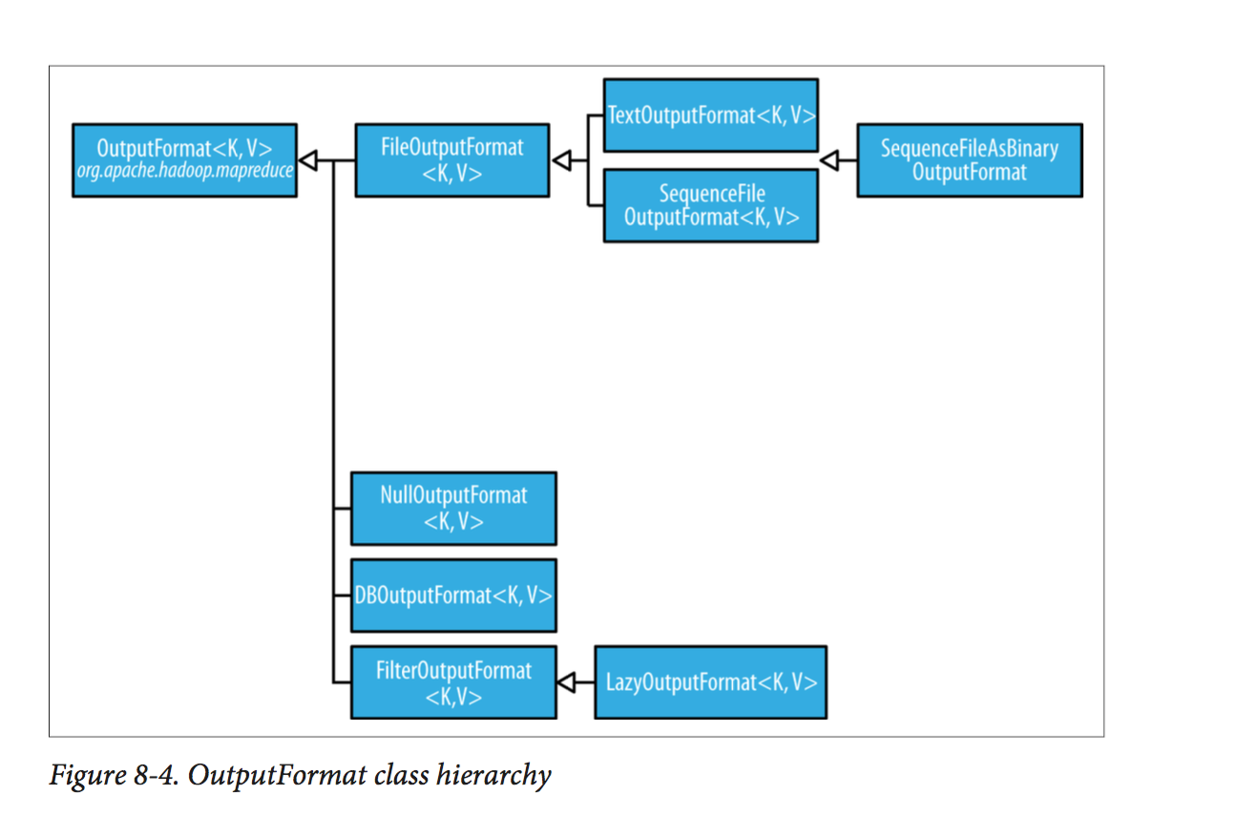

### FileOutputFormat

#### TextOuputFormat

**The default output format**, TextOutputFormat, writes records as lines of text. **Its keys and values may be of any type, since TextOutputFormat turns them to strings by calling toString() on them.**

Each key-value pair is separated by a tab character, although that may be changed using the mapreduce.output.textoutputformat.separator property. The counterpart to TextOutputFormat for reading in this case is KeyValue TextInputFormat, since it breaks lines into key-value pairs based on a configurable separator

### NullOutputFormat

You can decide not to write any ouput using NullOutputFormat.

You can supress writing key or value using NullWritable type.

### Binary Output

#### SequenceFileOutputFormat

writes sequence files for its output.

**This is a good choice of output if it forms the input to a further MapReduce job, since it is compact and is readily compressed.**

#### SequenceFileAsBinaryOutputFormat

SequenceFileAsBinaryOutputFormat—the counterpart to SequenceFileAsBinaryInputFormat—writes keys and values in raw binary format into a sequence file container.

#### MapFile, SetFile, ArrayFile, BoolFile OuputFormat

<http://blog.cloudera.com/blog/2011/01/hadoop-io-sequence-map-set-array-bloommap-files/>

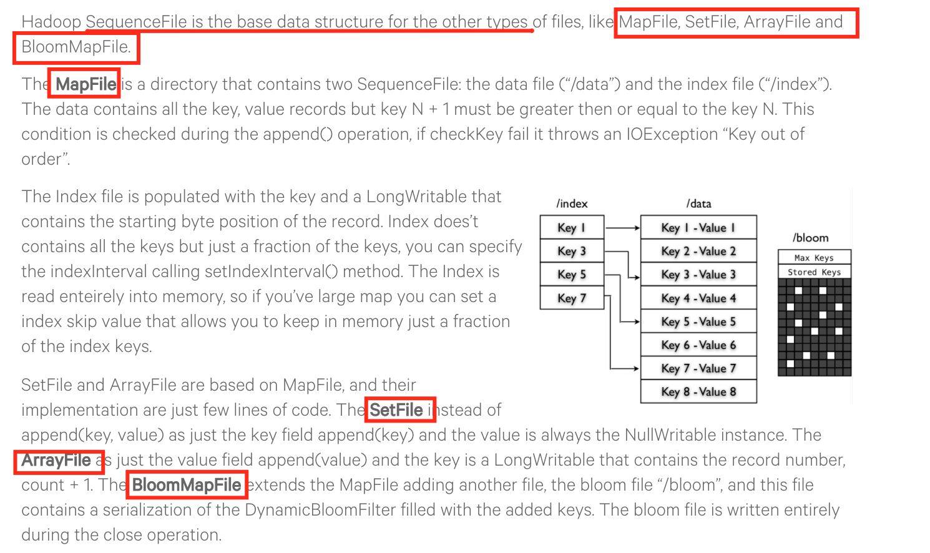

MapFileOutputFormat writes map files as output. The keys in a MapFile must be added in order, so you need to ensure that your reducers emit keys in sorted order.

NOTE:

The reduce *input* keys are guaranteed to be sorted, but the output keys are under the control of the reduce function, and there is nothing in the general MapReduce contract that states that the reduce *output* keys have to be ordered in any way. The extra constraint of sorted reduce output keys is just needed for MapFileOutputFormat.

### DatabaseOutputFormat

The output formats for writing to relational databases and to HBase are mentioned in Database Input/Output Format section.

# Multiple Inputs (More Than One Mappers for Different Sets of Input Files)

(pg 237 of book)

MultipleInputs class, which allows you to specify which InputFormat and Mapper to use on a per-path basis.

MultipleInputs.addInputPath(job, ncdcInputPath,

TextInputFormat.class, MaxTemperatureMapper.class);

MultipleInputs.addInputPath(job, metOfficeInputPath,

TextInputFormat.class, MetOfficeMaxTemperatureMapper.class);

This code replaces the usual calls to FileInputFormat.addInputPath() and job.setMapperClass().

# Multiple Outputs (More than one output files from a reducer)

**FileOutputFormat and its subclasses generate a set of files in the output directory. There is one file per reducer, and files are named by the partition number: *part-r-00000*, *part- r-00001*, and so on. Sometimes there is a need to have more control over the naming of the files or to produce multiple files per reducer.**

Normally, number of output files are same as number of reducers.

part-r-00000, part-r-00001 etc. if there are no reducers, just mappers, then part-m-00000, part-m-00001 etc.

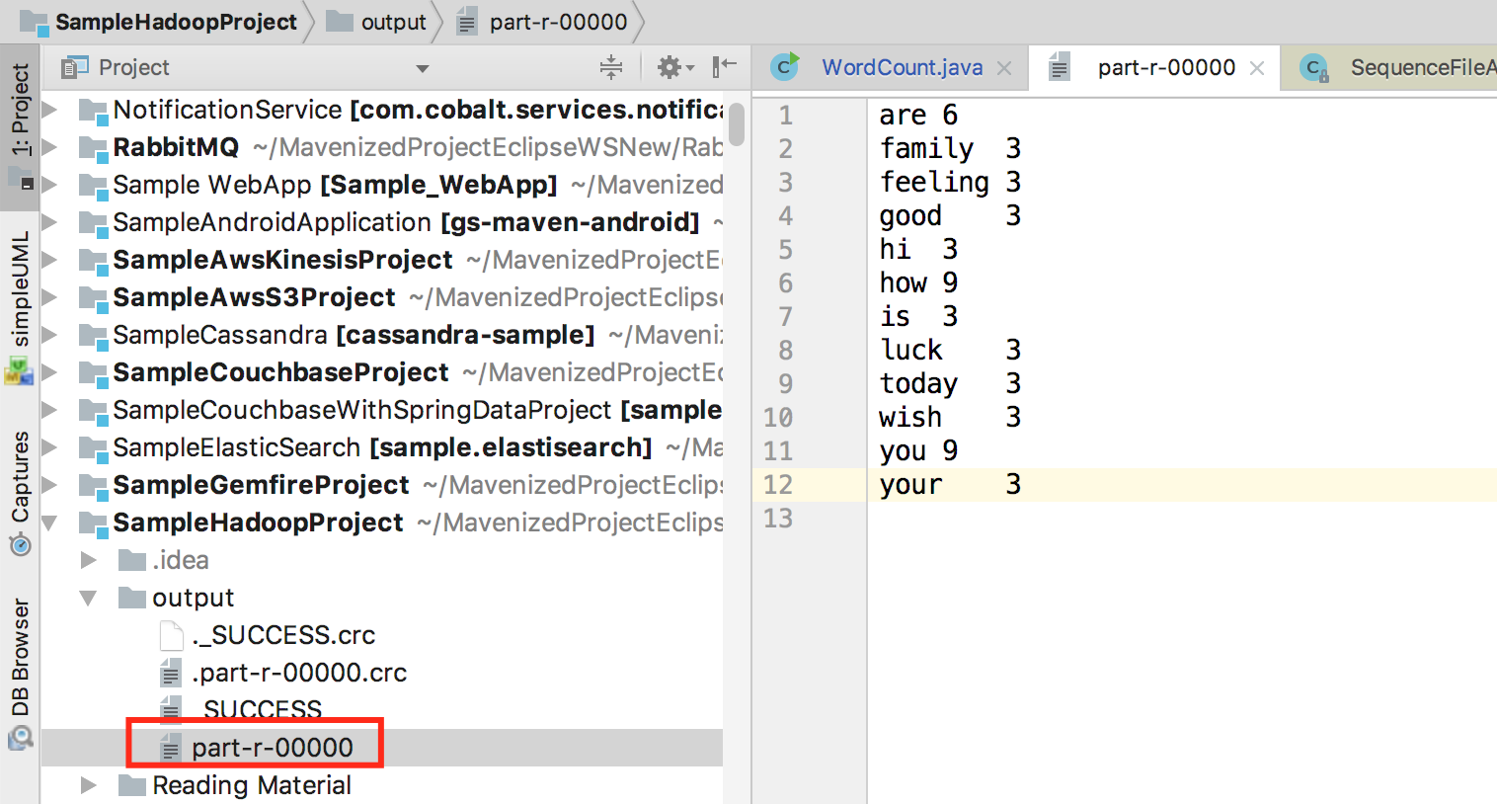

Let’s say in WordCount example, you want to create output file of reduce that are separated by first letter of the word. It means you want to create multiple output files from one reducer based on the name of the files that you specify.

a-r-00001 – contains “are 6”

f-r-00002 – contains “family 3, feeling 3”

etc.

**you can write custom partitioner that reads first letter of the word and based on that it puts that word in particular partition. It will still create one output file per reducer.**

There are **drawbacks** to this method.

* You need to fix number of reducers based on number of letters that are available in your input file.

So, since the number of partitions needs to be known before the job is run, so does the number of weather stations.

* It is generally a bad idea to allow the number of partitions to be rigidly fixed by the application, since this can lead to small or uneven- sized partitions. Having many reducers doing a small amount of work isn’t an efficient way of organizing a job; it’s much better to get reducers to do more work and have fewer of them, as the overhead in running a task is then reduced. Uneven-sized partitions can be difficult to avoid, too.
* If a few reduce tasks take significantly longer than the others, they will dominate the job execution time and cause it to be longer than it needs to be.

It is much better to let the cluster drive the number of partitions for a job, the idea being that the more cluster resources there are available, the faster the job can complete. This is why the default **HashPartitioner** works so well: it works with any number of partitions and ensures each partition has a good mix of keys, leading to more evenly sized partitions.

**Another solution is use MultipleOutputs object instead of context to write output key-value.**

**It will create multiple output files from one reducer based on the name of the file that you provide. E.g. here key.toString() is given as prefix of the file.**

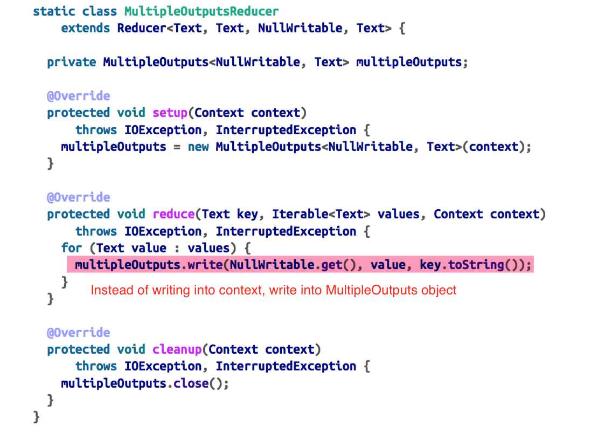

The write() method takes the key and value, as well as a name.

# Lazy Output

FileOutputFormat subclasses will create output (*part-r-nnnnn*) files, even if they are empty. Some applications prefer that empty files not be created, which is where LazyOutputFormat helps. It is a wrapper output format that ensures that the output file is created only when the first record is emitted for a given partition. To use it, call its setOutputFormatClass() method with the JobConf and the underlying output format.

Streaming supports a -lazyOutput option to enable LazyOutputFormat.

# MapReduce Features

## Counters

Counters are a useful channel for gathering statistics about the job: for quality control or for application-level statistics. They are also useful for problem diagnosis. If you are tempted to put a log message into your map or reduce task, it is often better to see whether you can use a counter instead to record that a particular condition occurred. In addition to **counter values being much easier to retrieve than log output for large distributed jobs**, you get a record of the number of times that condition occurred, which is more work to obtain from a set of logfiles.

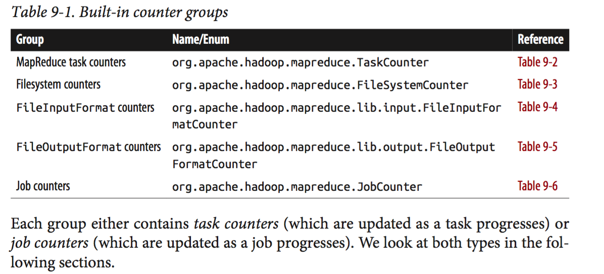

**Mainly Two types of inbuilt Counters:**

* **Task Counters**
* **Job Counters**

User can also define **user-defined counters.**

They give you information like memory and cpu used by tasks, map input records, reduce input records, map output records, reduce output records, number of uber tasks, number of successful/failed tasks etc.

### Task Counters

Counter values are definitive only once a job has successfully completed. However, some counters provide useful diagnostic information as a task is progressing, and it can be useful to monitor them with the web UI. For example, PHYSICAL_MEMORY_BYTES, VIRTUAL_MEMORY_BYTES, and COMMITTED_HEAP_BYTES provide an indication of how memory usage varies over the course of a particular task attempt.

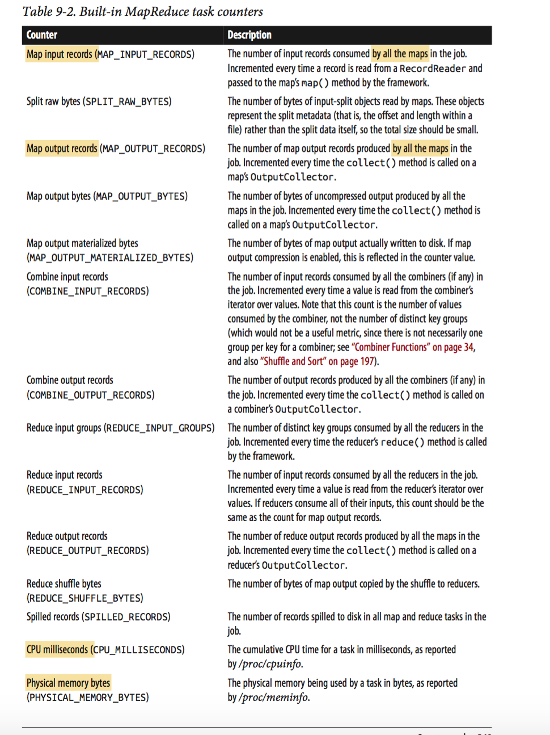

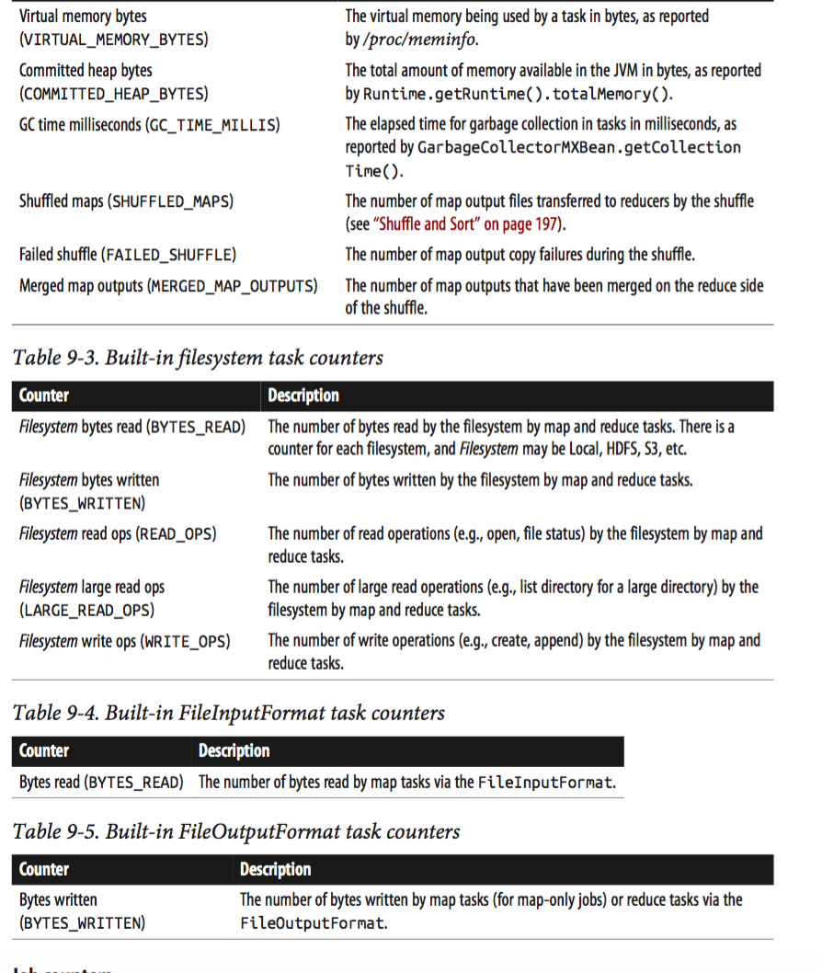

### Job Counters

Job counters are maintained by the application master, so they don’t need to be sent across the network, unlike all other counters, including user-defined ones. They measure job-level statistics, not values that change while a task is running.

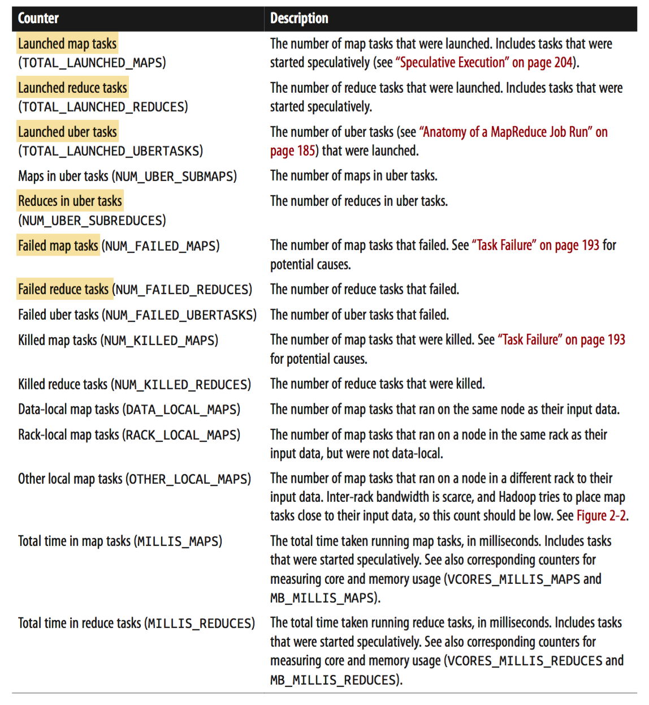

### User-Defined Counters

e.g.

@Override

**public void** map(LongWritable key, Text value, Context context) **throws** IOException, InterruptedException {

parser.parse(value);

**if** (parser.isValidTemperature()) {

**int** airTemperature = parser.getAirTemperature();

**if (airTemperature > 1000) {**

**System.err.println("Temperature over 100 degrees for input: " + value);**

**context.setStatus("Detected possibly corrupt record: see logs.");**

**context.getCounter(Temperature.OVER_100).increment(1);**

**}**

context.write(**new** Text(parser.getYear()), **new** IntWritable(airTemperature)); }

}

If the temperature is over 100°C (represented by 1000, because temperatures are in tenths of a degree), we print a line to standard error with the suspect line, as well as updating the map’s status message using the setStatus() method on Context, directing us to look in the log. We also increment a counter, which in Java is represented by a field of an enum type. In this program, we have defined a single field, OVER_100, as a way to count the number of records with a temperature of over 100°C.

Retrieving the counter in client code (driver class code)

Counters counters = job.getCounters();

**long** missing = counters.findCounter(MaxTemperatureWithCounters.Temperature.MISSING).getValue();

**long** total = counters.findCounter(TaskCounter.MAP_INPUT_RECORDS).getValue();

# Sorting

The ability to sort data is at the heart of MapReduce.

In this section, we examine different ways of sorting datasets and how you can control the sort order in MapReduce.

There are 3 types of getting sorted data as job output.

* Partial sort
* Total sort
* Secondary sort

<http://blog.ditullio.fr/2016/01/04/hadoop-basics-total-order-sorting-mapreduce/>

Partial sort

each reducer produces one output file sorted by key in output file. If you have multiple reducers, you will have multiple output files, each one is sorted by key.

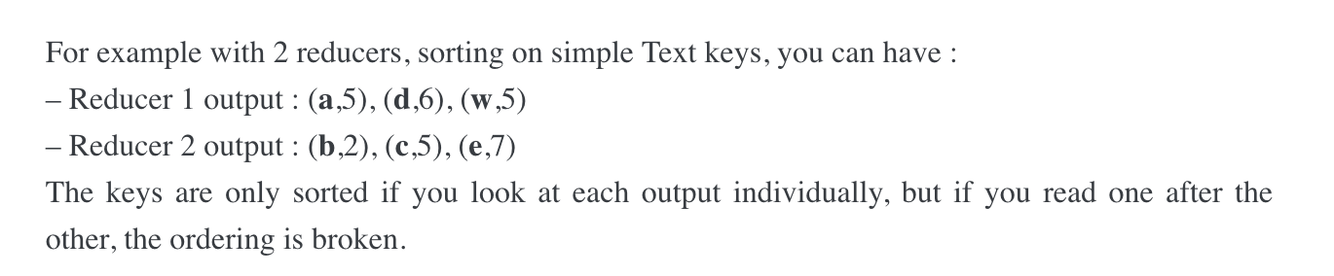

Total sort

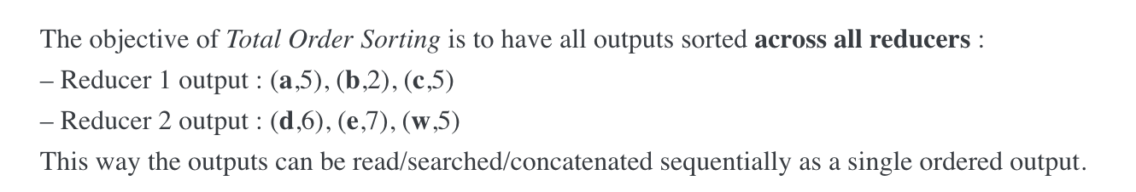

One way to do that is to write customer partitioner that does something like below. **But custom partitioner can created load imbalance problem between multiple reducers.**

**There is a possibility that keys that starts with A to I are a lot more than other two. In this case one reducer will produce more output than other two and also will take more time to process the records.**

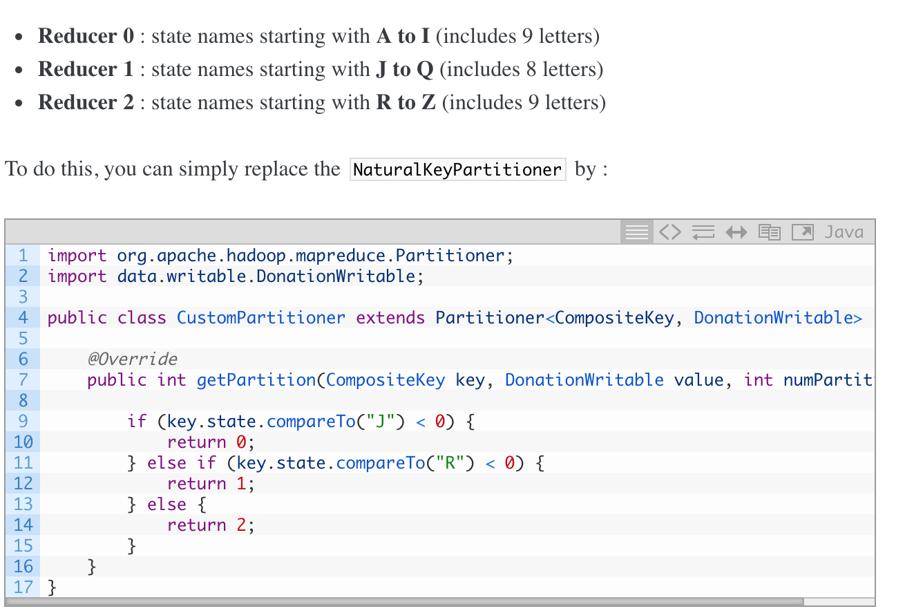

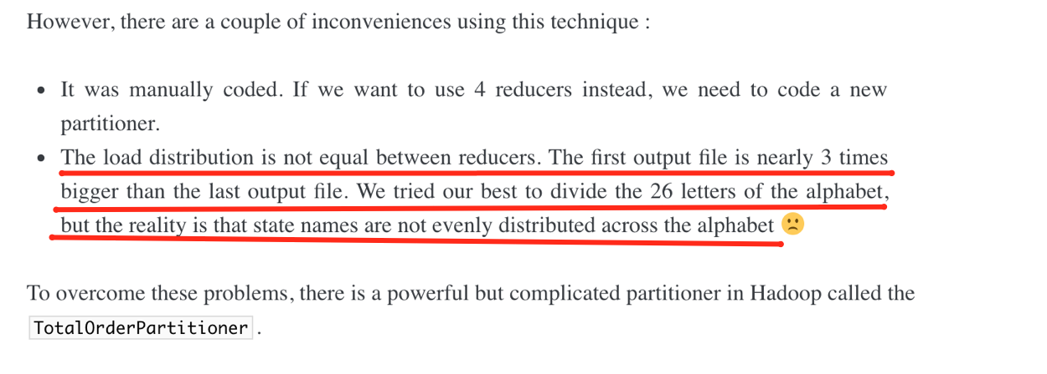

Another way is to use TotalOrderPartitioner ‘job.setPartitionerClass(TotalOrderPartitioner.class)’

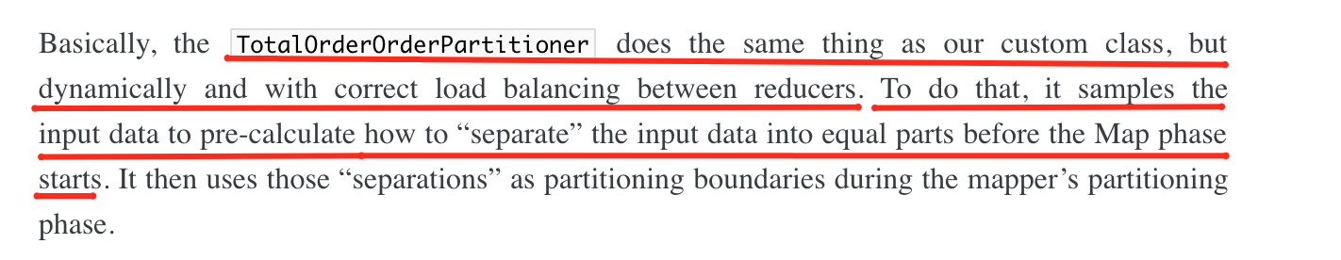

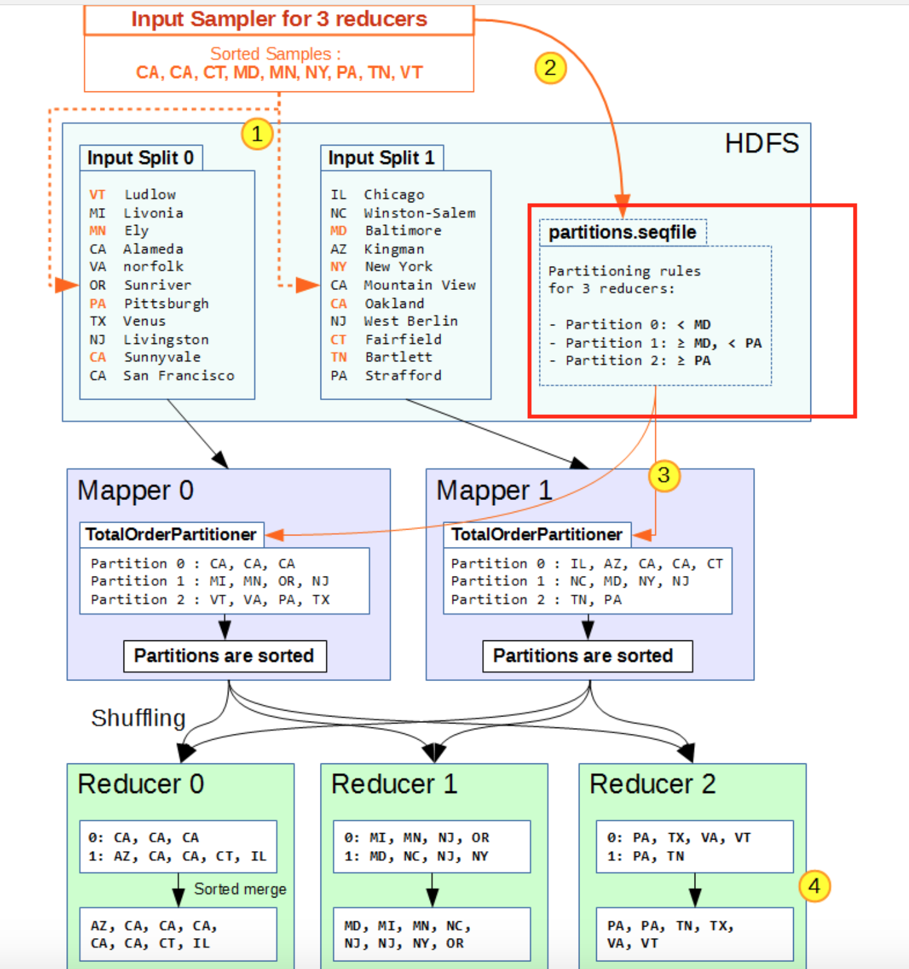

Secondary sort

In this case, we will be able to control the ordering of the values along with the keys. That is sorting can be done on two or more field values.

<https://www.safaribooksonline.com/library/view/data-algorithms/9781491906170/ch01.html>

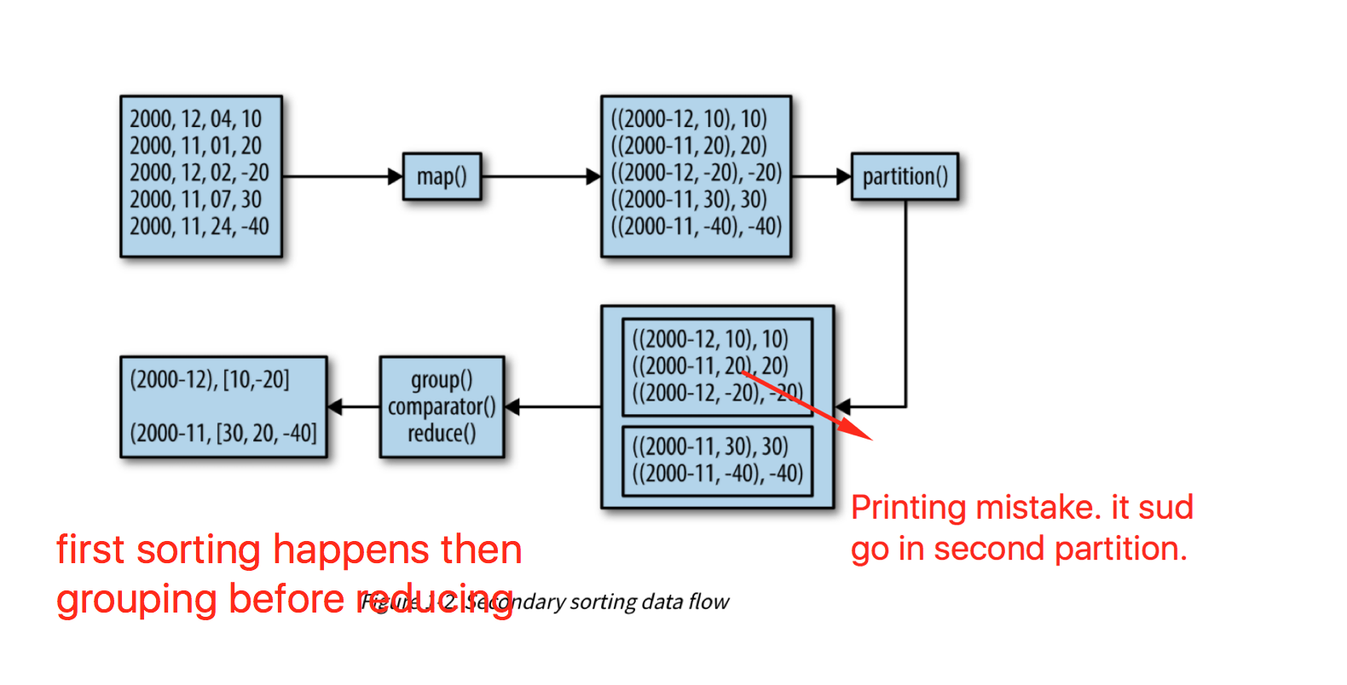

You want output of reducer as above.

You need to use secondary sort.

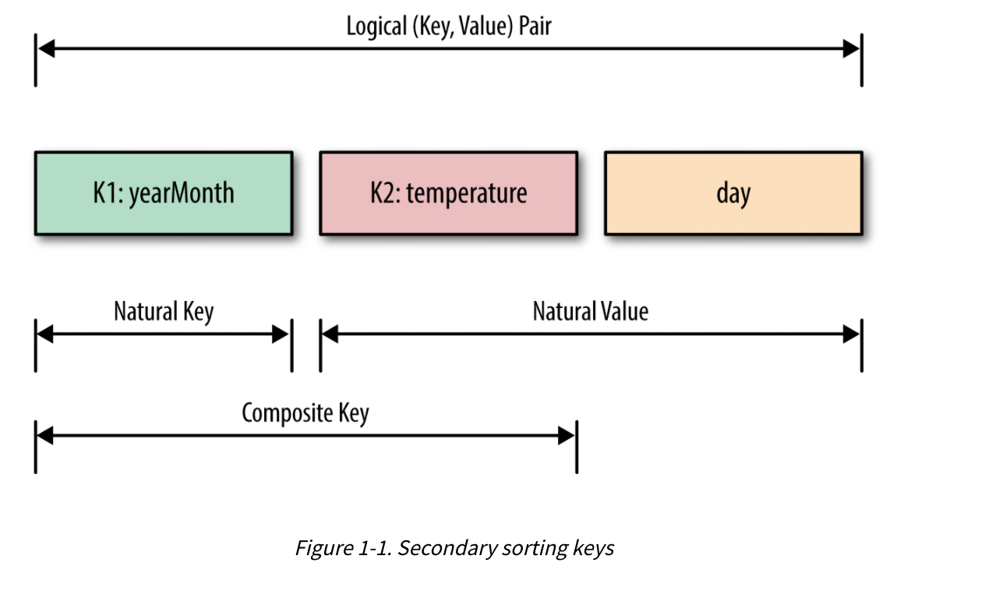

In secondary sort, you need to use both year-month and temperature as an output key of mapper.

you need to use **DateTemperaturePair** as a writable. DateTemperaturePair has **two variables – year-month and temperature** (Day is not required even though it is shown in below example). All Writables have to be of type Comparable also. So, **DateTemperaturePair implements WritableComperable**. So, it overrides **compareTo()** method that will be used for sorting. It first compares year-month, if both are same then it compares temperature.

It’s a descending sorting.

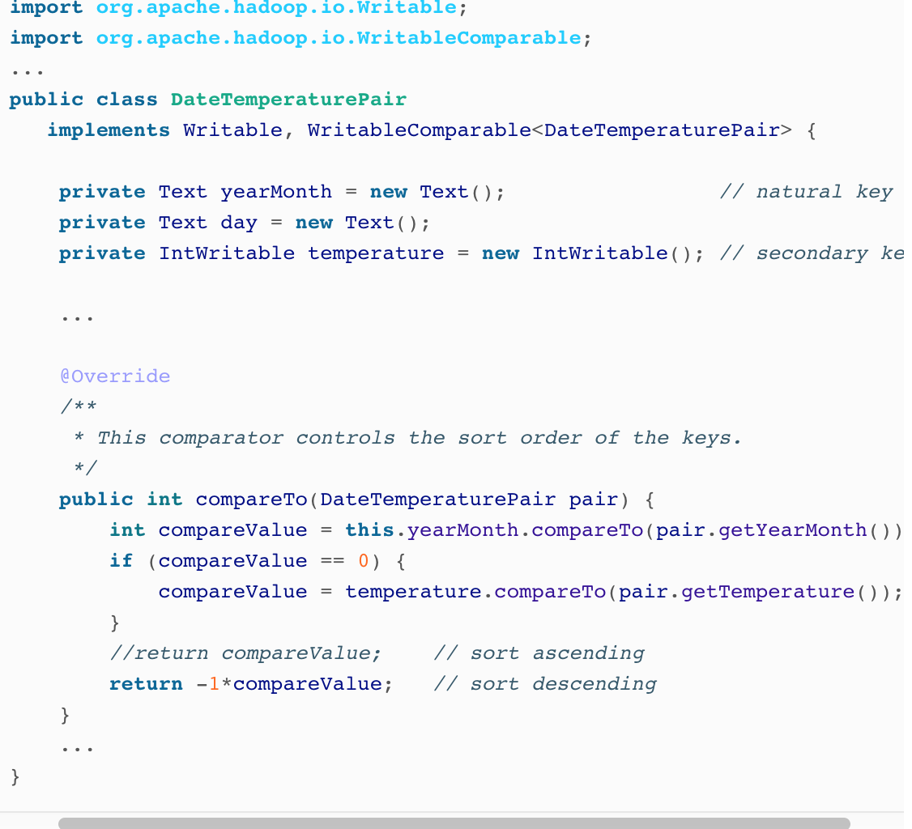

Mapper

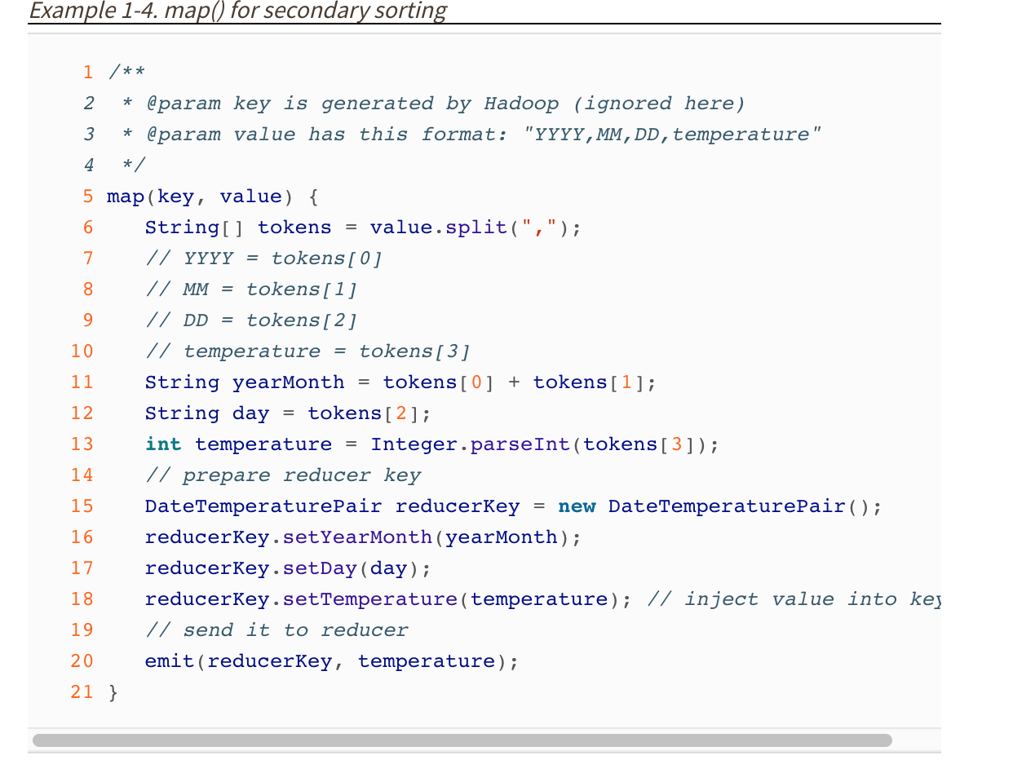

Partitioning should happen based on year-temperature only. So you need to implement custom partitioner that returns a partition number based on DateTemperaturePair’s yearMonth variable.

partition 1

((2012-12, 10), 10)

((2012-12, -20), -20)

partition 2

((2012-11, 30), 30)

((2012-11, 20), 20)

((2012-11, -40), -40)

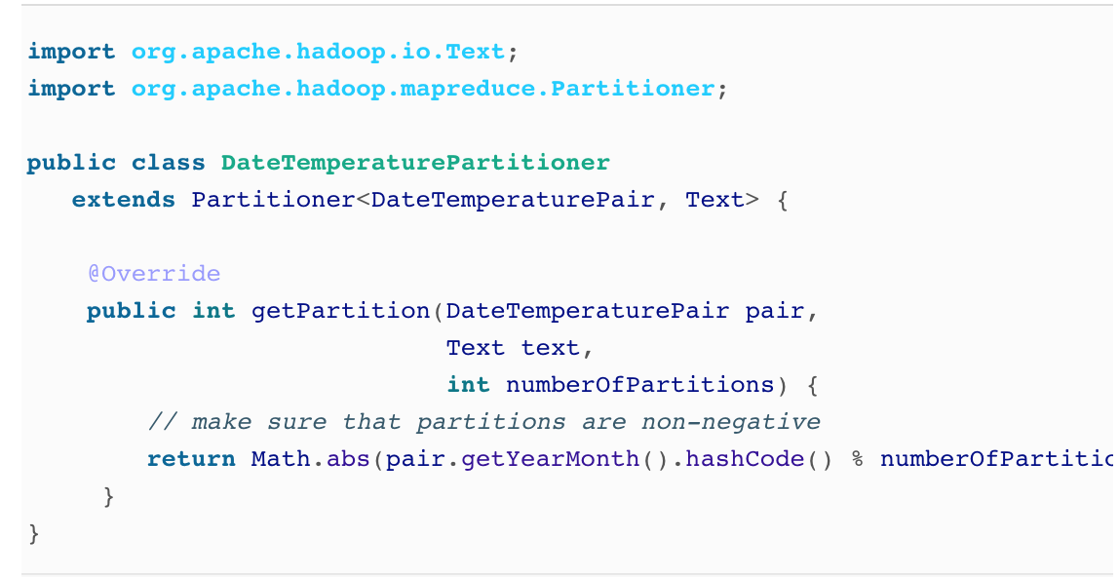

Grouping should happen only on year-temp

Input to Reducer1

((2012-12, 10), [10, -20])

Input to Reducer 2

((2012-11, 30), [30,20,-40])

You need custom Comparator for Grouping that compare only YearMonth.

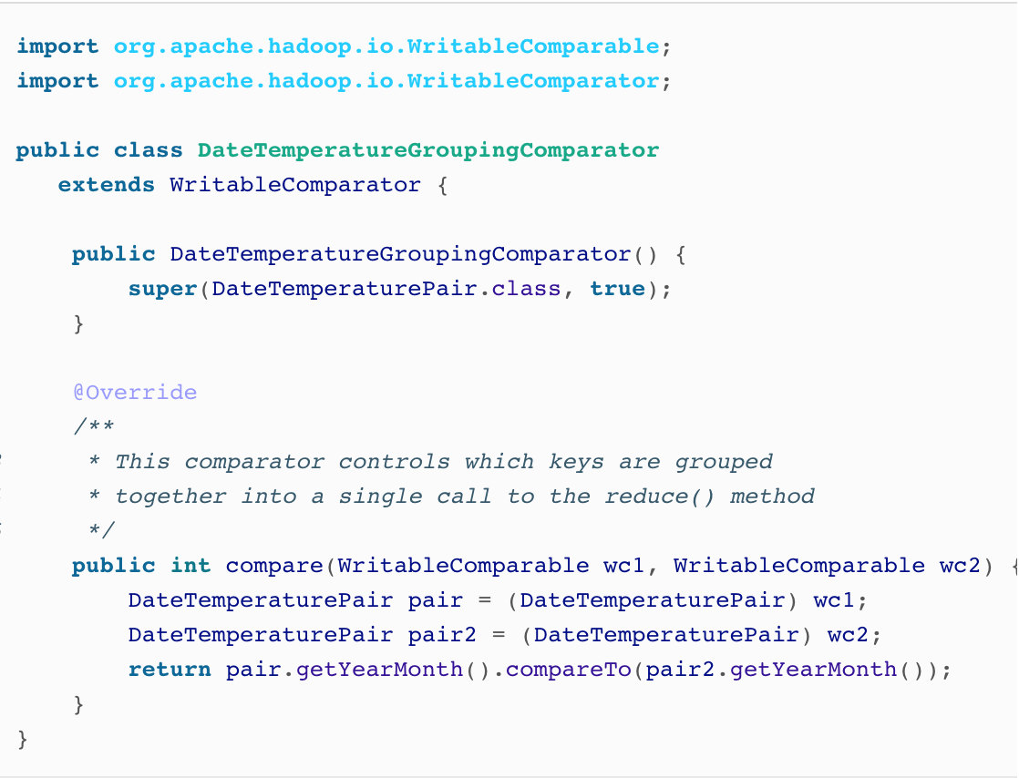

Reducer

public class MyReducer extends Reducer<DateTemperaturePair, IntWritable, Text, Text> {

protected void reduce(TextPair key, Iterable<IntWritable> values, Context context) {

String finalValue = “”;

iterator<IntWritable> it = values.iterator();

while(it.hasNext()) {

finalValue += “,” + it.next();

}

context.write(key.getYearMonth().toString(), “\t”+finalValue);

}

}

Output of Reducer1

(2012-12 10,-20)

Output of Reducer2

(2012-11 30,20,-40)

Client/Driver Class

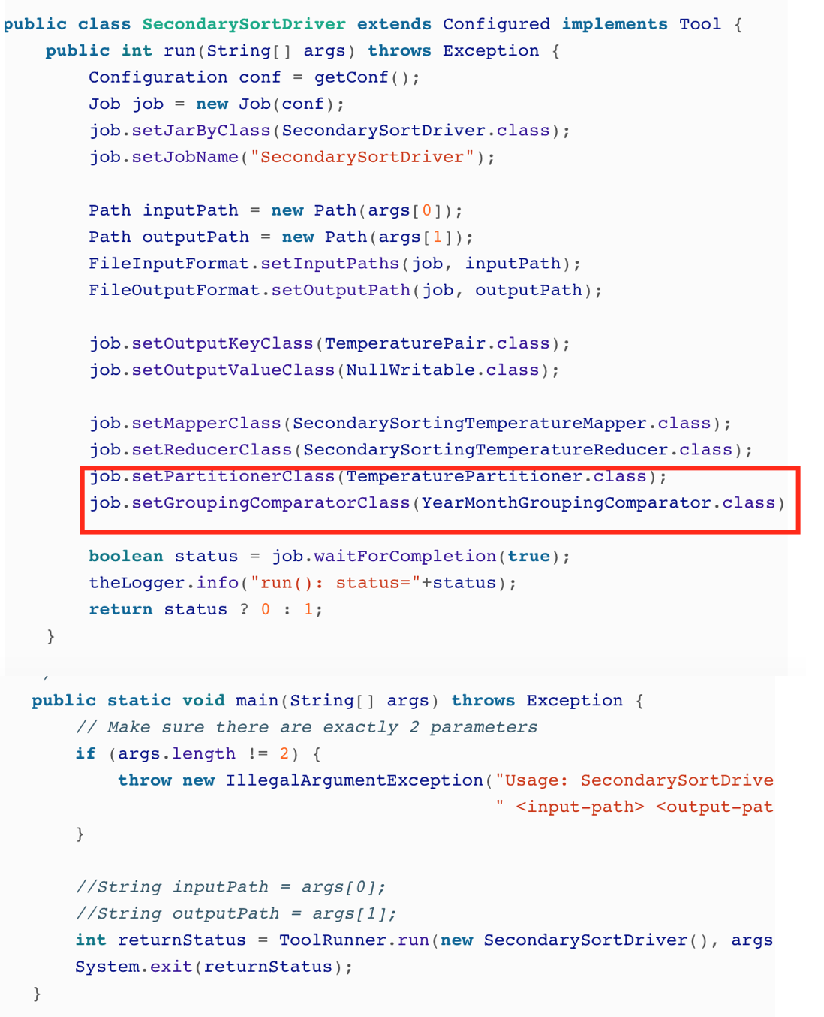

# Joins

MapReduce can **perform joins between large datasets, but writing the code to do joins from scratch is fairly** involved. **Rather than writing MapReduce programs, you might consider using a higher-level framework such as Pig, Hive, Cascading, Cruc, or Spark**, in which join operations are a core part of the implementation.

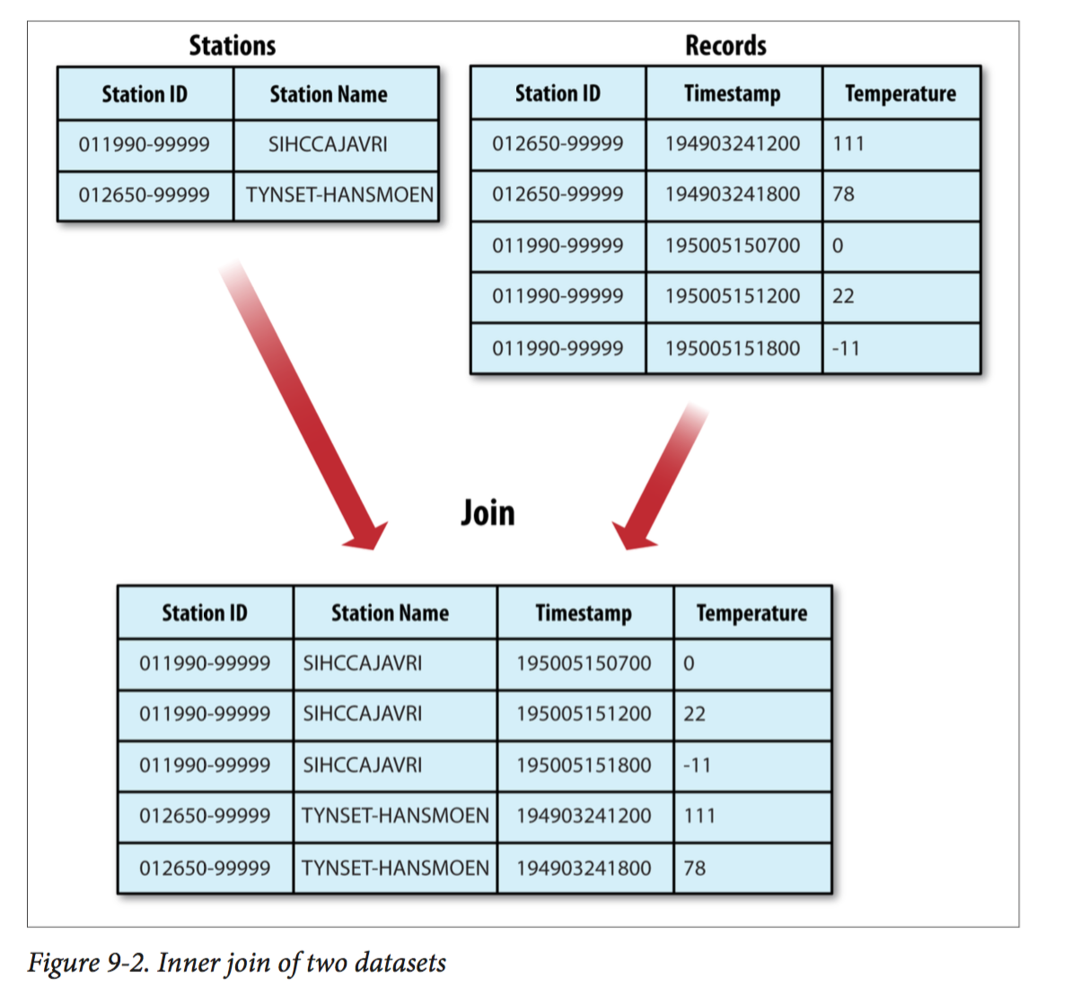

If the join is performed by the mapper it is called a ***map-side join***, whereas if it is per‐

formed by the reducer it is called a ***reduce-side join***.

## Map-Side Join

A map-side join between large inputs works by performing the join before the data reaches the map function.

For this to work, though, the inputs to each map must be partitioned and sorted in a particular way.

Each input dataset must be divided into the same number of partitions, and it must be sorted by the same key (the join key) in each source. All the records for a particular key must reside in the same partition. This may sound like a strict requirement (and it is), but it actually fits the description of the output of a MapReduce job.

You use a **CompositeInputFormat** from the org.apache.hadoop.mapreduce.join package to run a map-side join. The input sources and join type (inner or outer) for CompositeInputFormat are configured through a join expression that is written ac‐ cording to a simple grammar.

## Reduce-Side Join

A reduce-side join is

* more general than a map-side join, in that the input datasets don’t have to be structured in any particular way,
* it is less efficient because both datasets have to go through the MapReduce shuffle.

We use several ingredients to make this work in practice:

*Multiple inputs*

The input sources for the datasets generally have different formats, so it is very convenient to use the MultipleInputs class

*Secondary sort*

Read secondary sort example properly. It will be easy to understand join example.

You can see how to implement join on pg. 270 of book.

You have two mappers for two different data sets.

TextPair is same as DateTemperaturePair object as explained in Secondary Sort example.

TextPair is the output key of mappers

Partitioning is done on only first variable of TextPair.

Sorting is done on the basis of TextPair’s comapreTo method (on both variables).

Grouping is done on TextPair’s first variable only.

As there are two data sets, there are two mappers and using MultipleInputs, inputs are given to mappers.

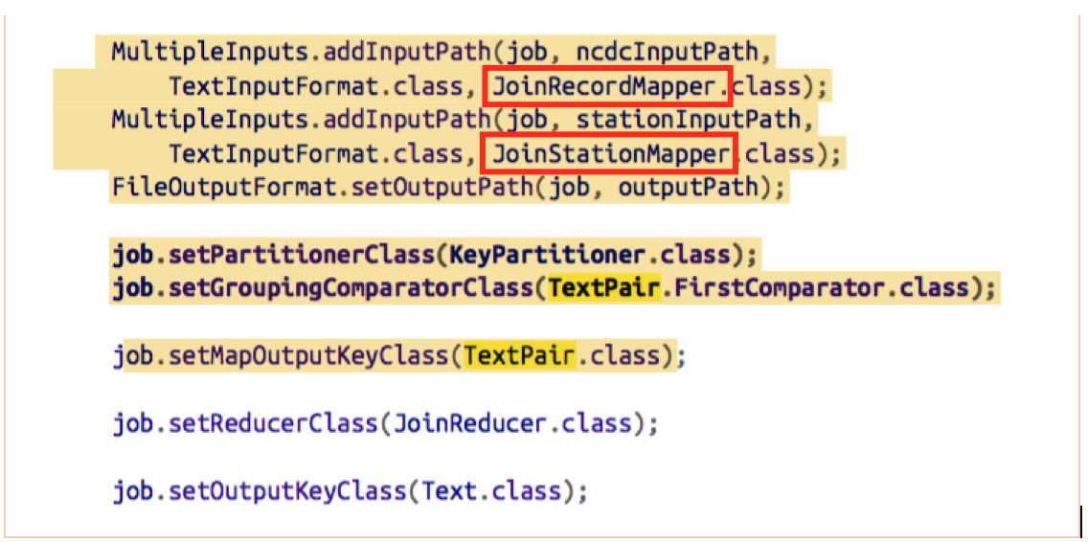

# Side Data Distribution

There is possibility that your mappers/reducers needs to sue some fixed static data while processing actual data sets. There are two ways to provide these kind of data.

* Using Job Configuration object

You already saw this previously.

* Using Distribute Cache

When you run the job, using –file option, you can tell Hadoop to copy this file to all task nodes. By default, it will be copied to local file systems of task nodes.

you can specify the files to be distributed as a comma-separated list of URIs as the argument to the -files option. Files can be on the local filesystem, on HDFS, or on another Hadoop- readable filesystem (such as S3). If no scheme is supplied, then the files are assumed to be local. (This is true even when the default filesystem is not the local filesystem.)

The -libjars option will add JAR files to the classpath of the mapper and reducer tasks. This is useful if you haven’t bundled library JAR files in your job JAR file.

% hadoop jar hadoop-examples.jar \ MaxTemperatureByStationNameUsingDistributedCacheFile \ **-files** input/ncdc/metadata/stations-fixed-width.txt input/ncdc/all output

This command will copy the local file *stations-fixed-width.txt* (no scheme is supplied, so the path is automatically interpreted as a local file) to the task nodes, so we can use it to look up station names.

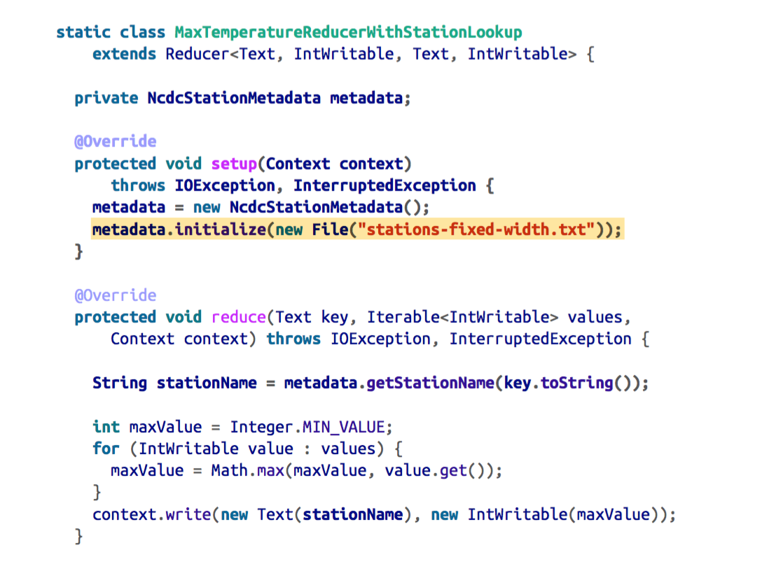

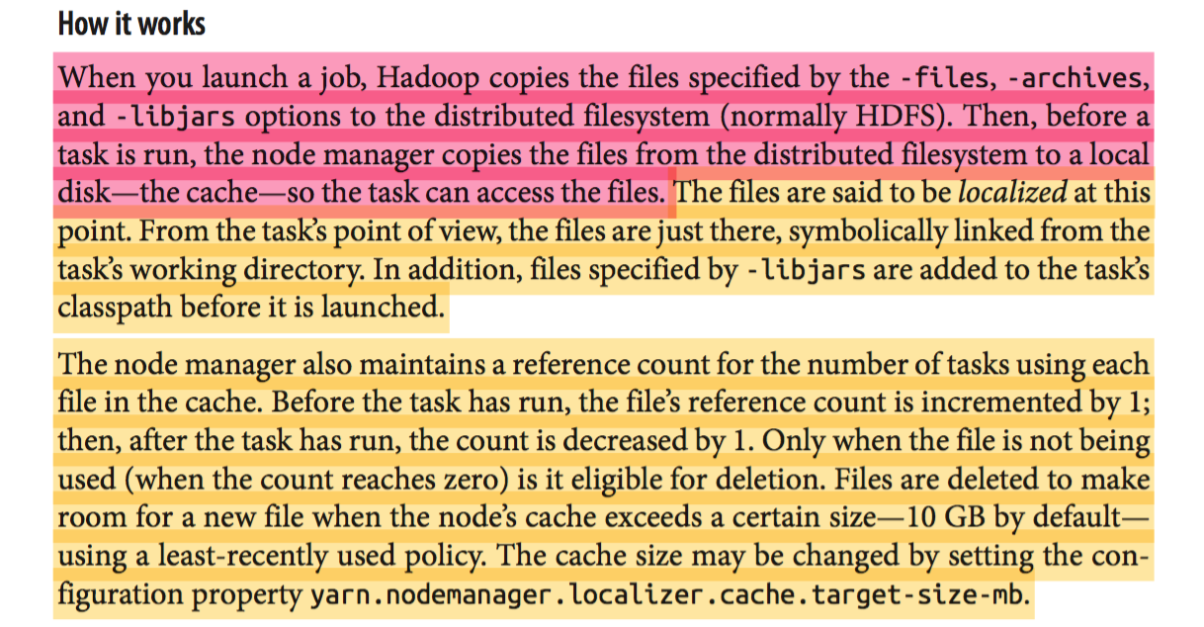

# Hadoop Related Projects

* 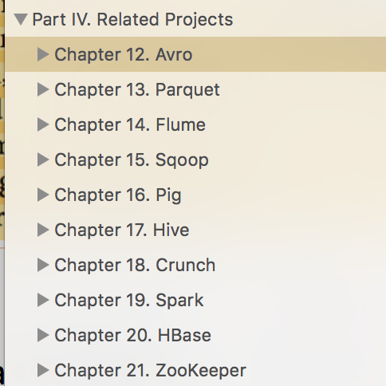

## Avro

<https://en.wikipedia.org/wiki/Apache_Avro>

**Avro** is a [remote procedure call](https://en.wikipedia.org/wiki/Remote_procedure_call) and data [serialization](https://en.wikipedia.org/wiki/Serialization) framework developed within Apache's Hadoop project. It uses [JSON](https://en.wikipedia.org/wiki/JSON) for defining data types and [protocols](https://en.wikipedia.org/wiki/Communications_protocol), and serializes data in a compact binary format. Its primary use is in [Apache Hadoop](https://en.wikipedia.org/wiki/Hadoop), where it can provide both a serialization format for persistent data, and a wire format for communication between Hadoop nodes, and from client programs to the Hadoop [services](https://en.wikipedia.org/wiki/Service_(systems_architecture)).

It is similar to [Thrift](https://en.wikipedia.org/wiki/Thrift_(protocol)) and [Protocol Buffers](https://en.wikipedia.org/wiki/Protocol_Buffers), but does not require running a code-generation program when a [schema](https://en.wikipedia.org/wiki/Database_schema) changes (unless desired for [statically-typed](https://en.wikipedia.org/wiki/Statically-typed) languages).